- Define nation and list characterisitcs of a nation
- What is the key problem of a nation-state?
- What’s the difference between a nation and a nation-state?

Political Terms Association triangle:
Directions: Define the words in context of political geography. Next to the arrows, explain how the words relate to one another (do NOT redefine them!). In the middle of the triangle, explain what all three have in common.
Colonization
State
Nationalism
Key Issue 2: Why have ethnicities been transformed into nationalities?

Nationality- the identity of a group of people who share legal attachment and personal allegiance to a particular country.
Self-determination- the concept that ethnicities have the right to govern themselves.
Nation-state- a state whose territory corresponds to that occupied by a particular ethnicity that has been transformed into a nationality. Denmark is an excellent example.
Ethnic groups have been transformed into nationalities because desire for self-rule is a very important shared attitude for many of them.
Nationalism- loyalty and devotion to a nationality.
Centripetal force- an attitude that tends to unify people and enhance support for a state.
Multi-ethnic state- a state that contains more than one ethnicity.
Multinational states- multi-ethnic states that contain two ethnic groups with traditions of self-rule that agree to coexist peacefully. The United Kingdom is an example. The Soviet Union was the largest multinational state until is fall in the early 1990s; it consisted of 15 different republics based on its largest ethnicities. Now Russia is the largest multinational state, with 39 nationalities.

4. What is the difference between a multistate nation and a multinational state?

After the fall of the Soviet Union, many new countries in the Baltic, E. Europe, and Middle East were created, sometimes corresponding to nationalities, sometimes not. An example of turmoil resulting from poorly drawn boundaries is in the Caucasus region, betwixt the Black and Caspian seas. Many ethnicities exist here, with several pushing for nationality.
Many Europeans believed at the beginning of the 20th century that ethnicities were a thing of the past, however, they were quite incorrect. After the fall of communism in many states, ethnicities that had long been suppressed were allowed to expand and flourish. This is especially evident in the former Yugoslavia, which was utterly decimated as minority ethnicities exerted themselves and demanded independence.
How Is Space Politically Organized into States and Nations?
Colonialism is at the heart of highly uneven global distribution of power that continues even today.
5. LOOK at the map on page 260 in your text….what patterns can you identify in terms of wealth and old colonial power around the globe today?

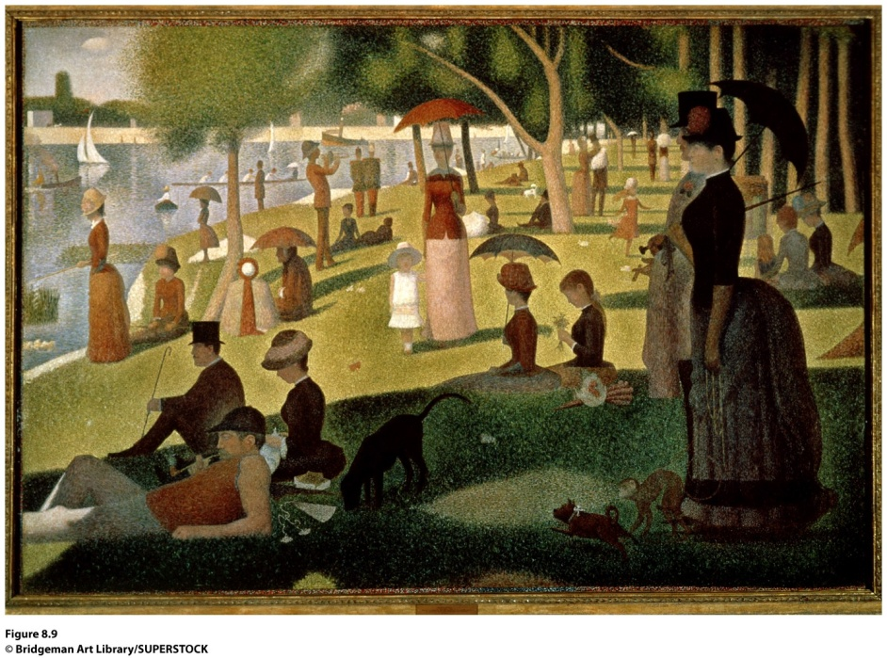
6. How does this painting by Seurat act as a metaphor for the world-systems theory?

7. Immanuel Wallerstein defines the world-system theory and contains three tenets (principles). They are
1.

2.

3.
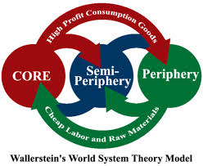
8. a. How you can explain the model to the left?
b. Are all core countries in the world today former colonial powers? (p. 263 in you text!)

How Do States Spatially Organize Their Governments?

Form of gov’t | definition | example | Important features
Unitary
Federal
9. Devolution (definition):
Devolutionary Forces

Force | Explanation | example | Important considerations
Ethnocultural
Economic
Territorial

Types of Boundary Disputes (p. 274 in book)
type | Explanation /definition | Example(s)
Definitional boundary disputes
Locational boundary disputes
Operational boundary disputes
Allocational boundary disputes

10. Describe how boundaries are established (include all four steps).

11. Describe the creation and purpose of the United Nation.

12. Describe the creation and purpose of the European Union.

13. The “state” as we know it is being challenged by (1) the demand of nations within states for independence, (2) the proliferation of nuclear weapons, (3) economic globalization, and (4) increasing connectedness among people and cultures. Using information from Ch 8, explain one of these challenges in more detail.

