Name_____________________________________________________________ Date_______________________ Period______
AP Human Geography- Final Project #1
Directions: Take a look at the table of contents on the next page. What better gift can you give next year’s crop of students but your knowledge! You will take your newly acquired Human Geography expertise and create summary/cheat sheets for key concepts and ideas. Each student in AP Human Geography will be choose a topic from the table of contents-NO ONE CAN REPEAT TOPICS: Each student will put together a 1-page information sheet regarding their topic. Please see the rubric for scoring guidelines, but keep in mind the objective.

- NO GROUPS OR PARTNERS: THIS IS AN INDIVIDUAL PROJECT
- Freshman, Sophomore, Juniors: Choose 1 topic and complete the review page.
- Seniors: you have to complete 2 pages! This counts as your FINAL EXAM GRADE; use your 3-day weekend to your advantage

Objective: To analyze an AP HuG topic in order to thoughtfully explain main points, ideas, and real world applications.
Page #1 is attached as a sample- improvement can always be made!
 | Points | Student Grade | Teacher Grade
Content  25 Points | Full and accurate description of your topic. Presented with AP level real world applications. Reference to both textbook material and outside sources are evident. Appropriate number and type of graphics are included and enhance your written information. Shows mastery of the objective and the given topic.
Overall Presentation of Topic  25 points | Items are clearly introduced (in a logical order and labeled), well-organized, and creatively displayed.  Precise and concise wording is used to present details. All text is a readable size and font (comparable to Times New Roman font, size 11 or 12)
Examples/Graphs/ Diagrams/ Pictures  15 points | Effectively use real world examples- when applicable. Images are appropriate and cited. Visuals contain additional information
Mechanics/Formatting/Directions  10 points | No spelling or grammar errors exist. TEXT IS IN THE AUTHOR’S OWN WORDS. Textbook pages are referenced/cited, when applicable. Two copies are turned in- one with your name in top right corner, one without your name. Page number in the bottom right-hand corner. Title placed top-center. Paper is printed in gray-scale (no colored pictures). One, single-sided, typed page. All written and verbal directions are followed.

Score __________/75

2014-2015 BIG IDEA PACKET- GET A 5!
Page # | Title
Nature/Perspectives
1 | Geographic Perspectives (space, location, scale, pattern, site, situation)
2 | Types of Maps
3 | Map Projections
4 | Geospatial Technologies (Remote Sensing, GIS, GPS)
5 | Cultural Regions
6 | Globalization of Economy and Culture
7 | Connection between places (diffusions)
8 | Sustainability (renewable and non-renewable resources)
9 | Earth’s Physical Systems (atmosphere, lithosphere, hydrosphere, biosphere)
10 | Environmental determinism and possibilism
Population and Migration
11 | Population Distribution (Human Factors- Political, Social, Economic) (Physical Factors- relief, resources, climate)
12 | Population Density (Arithmetic and Physiological)
13 | Key Population Statistics (crude birth/death rates, NIR, Doubling Time, TFR, IMR)
14 | Population Pyramids
15 | Demographic Transition Model
16 | Malthusian Theory
17 | Population Policies (Pro-Nationalist: France, Russia, Japan) (Anti-Nationalist: China and Singapore)
18 | Women and Population (Education, Fertility, Mortality, Politics, Economics)
19 | Aging Populations (causes and effects)
20 | Epidemiologic Transition Model
21 | Types of Migration
22 | Historical Migration (Forced: Atlantic Slave Trade, Immigration to the U.S., 15th Century European Explorers)
23 | Push and Pull Factors (Political, Environmental, and Economic)
24 | Consequences of Migration (Impacts on Destination and Source Countries) (Remittances)
Political Organization of Space
25 | Basic Terminology (Sate, Nation, Nation-State, Stateless Nation, Multi-national States, Multi-state Nations
26 | Colonialism
27 | Types of Boundaries
28 | State Shapes (include enclave and exclave)
29 | Forms of Government (Unitary, Federal States, Confederations) (Centralized, Decentralized, in-between) (Pros/Cons)
30 | Electoral Geography/Internal Boundaries (Census, reapportionment, redistricting, and Gerrymandering)
31 | The Cold War (Allies, terms, Domino Effect, Fall of Communism, Formation of new States)
32 | Supernationalism (EU, United Nations, NATO, ASEAN. NAFTA- countries involved, goals/purposes)
33 | Devolution (Definition, cause, examples, advantages, changes as a result of)
34 | Political Power (Definition of Territorial, Ratzel’s Theory, Mackinder’s Heartland Theory, Spykman’s Rimland Theory)
35 | Centripetal and Centrifugal Forces (please include Raison D’etre)
Development
36 | The Industrial Revolution (What, when, where, why, technology, Diffusion phases)
37 | Economic Sectors (Definition, primary through Quinary and examples)
38 | Location Models (Least Cost Theory, Locational Interdependence Theory, and Zone of Profitability)
39 | Measures of Development (GNI, TFR, IMR, HDI, Access to Healthcare, Gender Inequality, Income Distribution, Literacy Rates)
40 | Rostow’s Stages of Economic Growth
41 | Wallerstein’s World System’s Theory, Core, Periphery, Semi-Periphery
42 | UN Millennium Development Goals
43 | Women and Economic Development (women in the workforce, inequality, TFR)
44 | Fair Trade
45 | Growth Poles (Tech centers, Universities, Research triangle, and Silicon Valley)
46 | Energy Resources and Development
Agriculture
47 | First Agriculture Revolution (Neolithic Revolution)
48 | Second Agriculture Revolution
49 | Green Revolution
50 | Diet, Nutrition, and Hunger
51 | Types of Agriculture (Substinence- Shifting Cultivation, Pastoralism, Wet Rice Farming, Smallholder Crop & livestock Farming) ( Commercial Agriculture- Agribusiness, plantation, Mediterranean, Mixed Crop & livestock Farming, Livestock Ranching, and commercial gardening)
52 | Agricultural Regions (Shifting Agriculture, Pastoral Nomadism, Soybeans & Corn Production, Mediterranean Regions, Dairy Belt, and Bread Bowl)
53 | Von Thunen
54 | Responses to Modern Agriculture (Organic, GMO’s, and Eat Local Movements)
55 | Role of Women in Agriculture (LDC’s, gender gap, etc.)
Urban
56 | U.S. Urban Models (Concentric Zone Model, Sector Model, Multi-Nuclei Model, Urban Realms/Galactic City Model)
57 | Suburbanization (Definition, Causes, Effects, time periods)
58 | Sustainable Urban Growth (Smart Growth-advantages/disadvantages, New Urbanism, Farmland Protection, Greenbelt)
59 | Urban Revival (Gentrification, Urban Revitalization)
60 | Primate Cities vs. Rank Size Rule
61 | Urban Hierarchy and Central Place Theory
62 | Megacities, World Cities, Gravity Model (Growth in world cities)
63 | City Models Beyond North America (Griffin-Ford Model, De Blij Model, McGee Model)
Culture Patterns and Processes
64 | Causes and Effects of Globalization (Communication, technology, cultural consequences, Advantages/Disadvantages)
65 | Cultural Diffusion (Definition, types of)
66 | Cultural Adoption (Acculturation, Assimilation, Multi-culturalism)
67 | Colonialism and Imperialism (Define, Major Players, Impact on Culture)
68 | Ethnic Religions (Judaism, Hinduism)
69 | Universal Religions (Buddhism, Christianity, Islam)
70 | Fundamentalism and Secularism
71 | Popular vs. Folk Culture (Define each, compare, conflicts between them)
72 | Major Language Families (Define Language/families, Aspects of 6 major Language Families)
73 | Breaking Down Language (Language Convergence, Language Extinction, Lingua Franca, Artificial Language, Dialect, Toponyms)

Geographic Perspectives
Space (Distribution of Features):
- An absolute area where it can be measured or a relative area where it can’t
  - EX. An absolute space that can be measured is Earth
  - EX. A relative space that cannot be measured is outer space
  - EX. Spatial thinking is when geographers think about the arrangement of people and activities and why they are distributed that way.
  - The arrangement of a feature in space is called distribution
Location:  While Distribution in the arrangement of a feature in space, location is the definition a specific place is in space.  - It can be absolute (exact) or relative (in relation to something else)  - The absolute location of Yorkville High School is:  797 Game Farm Road  Yorkville, IL 60506  - The relative location of Yorkville high school is across from Yorkville Library and Police Station | Place:  - A point in space distinguished by specific physical and social characteristics  - EX. Chicago, IL is distinguished by its political boundaries and physical landmarks  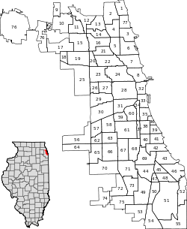  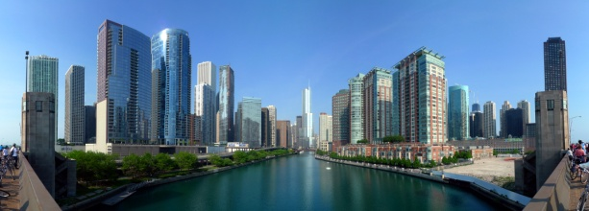
Scale:  - The proportion between the whole Earth and the size of the map being looked at. Scale can be local or global  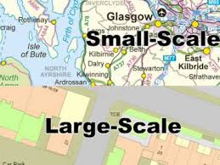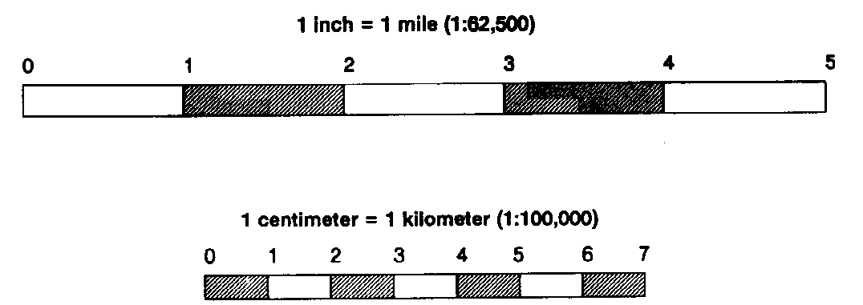 | Pattern:  - A property of distribution  - Geometric or regular arrangement of something in an area  - Often times, things are arranged in a square or a rectangle  - EX. Grid system in Chicago  - Streets intersect at right angles and are about the same intervals (same size in length) Remember- look for the trend, not the exception!
Site:  It is one way that geographers describe the location of a place (the other is by name or toponym)  - physical characteristic of a place, such as vegetation or topography  - EX. The Fox River is part of Yorkville’s site | Situation:  - The geographic context (think about when the teacher asks you to define a word in context) of a place, including its political, economic, and social characteristics  - EX. Turkey neighbors the Middle East, Europe, and North Africa. Because of its situation, Istanbul straddles the regions of Europe and Asia.  - Knowing the situation can help you find places  - EX. Do you know where the Yorkville Public Library is? Yes, it is over by the high school and Police Station

For more information see textbook pages: 8, 14-15, and 20-23. Page 1

