# [Source A] CHECK YOUR CLOTHING LABELS: Where Did Your Shirt Come From? And Why You Should Care *Garment workers are dying because of unsafe working conditions and employers who choose to ignore regulations and laws. So yes, it matters to me where my clothes were made. (*[*http://www.xojane.com/clothes/bangladesh-garment-workers-building-collapse*](http://www.xojane.com/clothes/bangladesh-garment-workers-building-collapse)*)* R. MELISSA MASOOM MAY 8, 2013

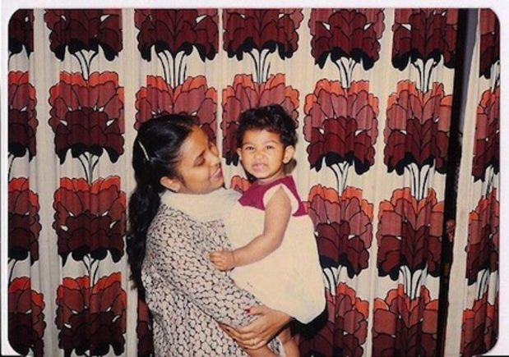My mother used to check the tags of everything we bought growing up. If the tag satisfied her, she’d buy it.  If it didn’t, it would go back on the rack. No, she wasn’t checking for designer labels. She was checking to see where it was made.

“Made in Bangladesh/India/Nepal” was a definite no. “Made in China” was a maybe. “Made in USA” was okay.It was annoying as a kid. Imagine being told that awesome Batman t-shirt you wanted was a no-go because of where it was made. It took years of hearing about how children my age were probably making that Batman t-shirt before my spoiled, American brat self got the picture.

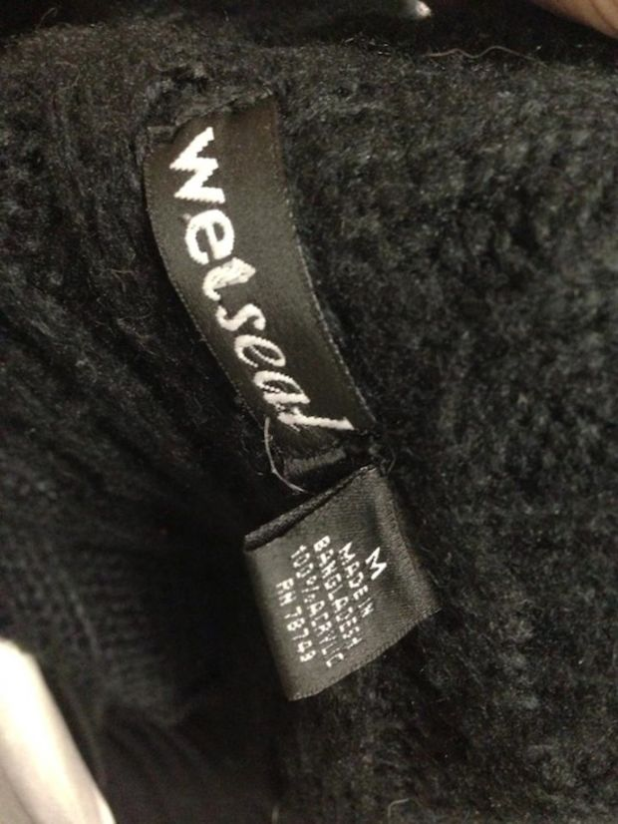The stories from Bangladesh, the country I was born in, are horrifying. My mother would tell me about how she grew up in Bangladesh in the middle class with six brothers and sisters in a neighborhood that was saturated with the signs of third world poverty. Though their house was a few stories high and they could afford new clothes and shoes, they could see the begging children, the families living in make shift tents on the street, and grown men defecating in the alleys from their veranda.  
  
Amongst all the poverty, she remembers how the millions of garment workers in the thousands of factories had some of the worst situations. Every other day there was a story about these workers, mostly women, protesting their working conditions and pay. She saw them lined up in front of the factories in the morning, some of them barely hitting puberty. They hardly made a living wage and worked in cramped, disgusting rooms.  
  
The faces of those women never left her. She still cannot make herself buy anything, years later in the States, that could possibly come from a place like that. As a result, I find myself almost 30 years later, still checking the tags of things I buy, feeling extremely guilty if someone even gives me something made in Bangladesh. I don’t always catch them all—especially if I’m online shopping—but it’s one of those things I’ve always been aware of.  
  
*(Damn it, Wet Seal sweater)*Recently, a building collapse in Dhaka killed hundreds—yes, hundreds—of workers, with hundreds still missing. Three of the stories of the building were built illegally and an order to evacuate issued by the police after cracks were seen the day before was ignored—just like the owners ignored various basic health and safety regulations, child labor laws, and other building regulations. The owners have [been arrested](http://www.cbc.ca/news/world/story/2013/04/28/bangladesh-building-collapse.html" \t "_blank) and rescuers are still trying to find the rest of the people trapped under the rubble for the last few days.  
  
It’s horrific. It’s enraging. It makes my blood boil. But it’s not surprising.

[Last November](http://www.guardian.co.uk/world/2012/nov/25/bangladesh-textile-factory-fire" \t "_blank) a fire in the same area in Dhaka killed over a 100 garment workers. Since 1990, more than[1,000](http://www.laborrights.org/creating-a-sweatfree-world/news/new-report-documents-fire-safety-cover-ups-by-us-retailers" \t "_blank) workers have died and several thousand more have been wounded in preventable Bangladesh factory fires and workplace incidents. Preventable, people. All these deaths and injuries were preventable.

On top of all of the other bullshit, the women in these Bangladeshi textile factories have to deal sexual harassment and discrimination, which [happen frequently](http://www.ijsst.com/issue/375.pdf" \t "_blank) in this industry that is 80 percent women. My own family members have told me how often they hear about women getting raped by their superiors or on their way to and from work. And these women rarely get maternity leave, a privilege so many of us in America take for granted.

*(Photo credit: ehstoday.com)*

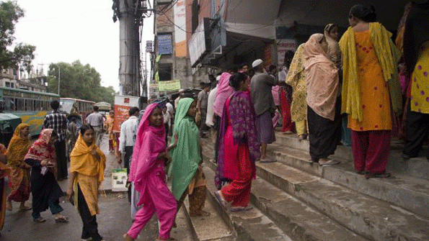Why can’t millions of people stand up to the few people running these operations? Well, would you want to be the whistleblower when you don’t have many other options to put food on the table? Bangladesh’s law and codes of conduct do actually allow for collective bargaining and worker’s rights—but anyone that does have the ovaries to stand up to their bosses and these companies often get repressed and abused even more (last year a labor organizer was[tortured and assassinated](http://www.globalpost.com/dispatches/globalpost-blogs/rights/bangladesh-labor-leader-tortured-murdered" \t "_blank)).

It’s absolutely wretched that big companies choose cheap clothing from cheap labor over doing the right thing. I’m sure when you’re sitting in a comfy office chair in a first world country so far removed from these men and women in other countries it’s easy to ignore what goes into making your wallet fatter. But that’s not an excuse.

We saw what happens when big companies here in the US ignore regulations with the recent West, TX tragedy—but at least this doesn’t happen as frequently here in the US (though terrible working conditions and sexual harassment in the workplace are a pretty big problem here too).

This is the one cause I have been supporting in my own little way for as long as I can remember. Just like my mother, the faces of those workers are in my subconscious, passed on through blood. The two recent events however were a wakeup call even to me and I realized what I was doing wasn’t nearly enough. Every day we’re supporting companies like Mango, Wal-Mart, and H&M that are ignoring where their clothes are coming from. And this is not ok, folks. Ethical clothing begins with us consumers.

So here I am enraged and pumped with adrenaline and chocolate covered espresso beans, [signing petitions](http://www.waronwant.org/overseas-work/sweatshops-and-plantations/17864-take-action-and-demand-justice-for-victims-of-bangladesh-building-collapse" \t "_blank) online, emailing organizations that might need legal help, and researching companies and their practices, wondering if any of it will make a goddamn difference. Either way, I need to do something. Maybe you all can help me brainstorm and spread the word?

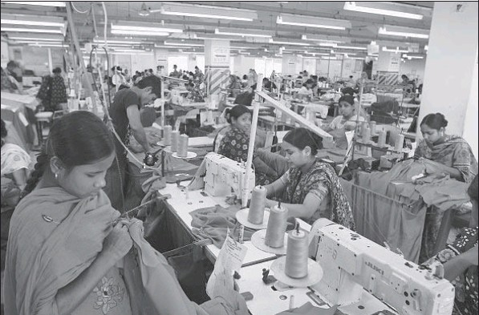**[SOURCE B] Bangladesh’s garment factories are likened to sweatshops. But such jobs give young women a degree of independence.** Photog raphs by Kenneth R. Weiss For The Times  
**BANGLADESH’S garment industry has earned a reputation for harsh and sometimes lethal working conditions. But the factory jobs also enable girls to make the transition from childhood to adulthood with relative independence in a traditional Muslim society.**

Mukhta Mollah deftly smooths the red fabric and guides it through a whirling sewing machine. She sews side seams on women’s blouses bound for America. Eight hours a day or longer in this hot and sweaty factory. Six days a week.

On this day, like every workday, she will try to reach a target of 1,000 blouses.

Seamstresses sit all around her in rows that stretch across this factory floor crowded with 350 workers. Fluorescent lights buzz and blink overhead. Enormous fans nosily push around the stagnant air, which carries the familiar scent of new clothes.

It takes Mollah less than 30 seconds to complete her part of the blouse. A helper snips the thread ends and piles the garments into a bin to take to the next station. Mollah has long grown accustomed to the mindnumbing repetition, the unrelenting din, the glare, the heat.

She knows that she won’t get rich; she sends nearly half of her $20-a-week wages home to her family. But she’s grateful that the salary, no matter how small, gave her the means to escape her home village and the fate of her schoolgirl friends.

All of them were married before age 16. All have children of their own. All have moved in with their husbands’ families and must get permission from their mothers-in-law to leave the house.

“For them, it’s a cage,” said Mollah, 19. “My life is much better than theirs because they have no freedom. When I go back to my village and see my friends, they ask me, ‘Can you take us with you?’ ”

Bangladesh’s garment industry has earned a reputation for harsh and sometimes lethal working conditions. An eight-story factory collapsed last April, crushing more than 1,100 workers. Six months earlier, a factory fire killed 112 people who could not flee because their bosses had locked the doors to keep them working.

Despite the horrific industrial accidents and accusations of labor abuses — such as forced workweeks of 80 hours — the picture of the underpaid and overexploited garment worker gets more complicated when compared with other options available to women in this poor, traditional Muslim society. About 5,600 factories in Bangladesh employ more than 4 million people; 90% of the workers are female.

“It’s not as dramatic of a transformation as a college education or launching a career,” said Sajeda Amin, a sociologist and demographer who has studied the societal impact of the garment industry for the nonprofit Population Council in New York. But these jobs, she said, have opened a new pathway for teenage girls to make the transition from childhood to adulthood with a measure of independence.

Even labor activists in Bangladesh and the United States who chronicle cases of workers being intimidated and forced to work long hours agree that the garment industry has given young women opportunities to move from the margins to the center of society.

“It’s fantastic that they have this common industry that has put women to work,” said Charles Kernaghan, director of the Institute for Global Labor and Human Rights, based in Pittsburgh. Recent street protests in Dhaka, the Bangladeshi capital, by garment workers helped nudge the minimum wage to $68 a month, which he said equates to 33 cents an hour. The industry, Kernaghan said, must do more to provide a decent living wage and respect workers’ rights.

The garment industry in Bangladesh is second only to China’s. It draws workers largely from rural areas such as the tiny village of two dozen houses near the Indian border where Mollah grew up with three sisters. The eldest worked for two years in a garment factory before returning home to marry.

When their father, a rice farmer, fell ill and was unable to work, Mollah willingly took the factory job to help the family. She was 15 at the time, a year older than the legal minimum age for a factory worker.

It’s lunchtime at Beauty Garments Pvt. Ltd., and Mollah spills out the door with most of the other 350 workers for the hourlong break. She meets up with three other young women — her roommates — as they are walking to their apartment.

All of them wear fashionable loose pants and tunics, called shalwar kameez, rather than the traditional flowing sari, making it easier for them to step over mounds of rubble and dirt piled alongside a deep trench in the road opened for sewer-line repairs.

Their two-bedroom flat is two blocks away; it is in a concrete structure with metal bars and shutters on the windows, but no glass panes.

The four live in a 10-foot-by-12-foot room, with a ceiling fan and a bare light bulb. Two sleep on a double bed, two on a pad on the concrete floor. The women switch places every other week and split the $45-amonth rent.

The second bedroom is occupied by a young married couple, who also work at the factory, and their 6-year-old daughter.

All share a squat toilet, a porcelain-lined hole in the floor, and a common kitchen with a low stool and two gas burners that sit on the floor. They cook in the kitchen and eat in their room. A refrigerator stands near the kitchen door, but the four women cannot use it because it is owned by the young couple. Their water comes from a community spigot 20 steps outside their front door.

Mollah and her roommates show off their apartment with pride, even though road dust blows through the windows, forcing them to keep their clothes bundled in bags. The paint is peeling, but the floor is meticulously clean. Floral pattern curtains cover the windows’ iron grating.

Kanchi Hazi, the more outgoing of the roommates who constantly makes the others laugh, said she considers the sleeping arrangements luxurious compared with those at the small house she shared with her parents, six sisters and two brothers.

The 24-year-old with a gap-toothed smile left her home village seven years ago to take this factory job. She sews pockets on blouses and works as many hours as she can get.

“I like it here,” she said, arms akimbo, with fists on her hips. “I make my own decisions. I can earn money and help my family.”

With overtime, she makes $78 a month and sends half of it home. Her father, a day laborer, cannot always find work. Every few months, she makes the three-hour bus ride home to visit her family. She gets mixed reactions from villagers.

Some adults praise her, she said, because “I’m the only wage earner in the family.” Others scold her for taking a job in a factory where men and women work together. It’s just not a proper place for a young, unmarried woman to be, they lecture.

But when she steps off the bus, younger village girls dance around her. “They see me as a role model,” Hazi said. “I can do whatever I want. I can enjoy myself. I have freedom.”

As more women earn money, this shift in economic clout is gnawing at the foundations of one of Bangladesh’s stubbornly enduring traditions. An estimated 60% of girls here marry before 18, the legal age for marriage. There’s evidence that girls lie about their age to registrars, and there’s little enforcement of laws against underage marriages. Most marriages are arranged by parents, who engage in a related practice that also violates the law but is rarely enforced: paying a dowry.

The dowry system skews toward marrying off daughters early, said Amin, the Population Council demographer who was born and raised in Bangladesh.

“We’ve been able to show very clearly that there’s a premium on young girls in terms of how they are valued in looks and malleability,” Amin said. “The older your daughter is, the more her worth goes down and you have to compensate with a larger dowry.”

Garment factory jobs have begun to undercut this long-standing custom, as parents — sometimes the daughters also speak up for themselves — challenge how much, if any, dowry is required when the bride-to-be earns a steady salary.

“These women aren’t rejecting arranged marriages,” Amin said. “They want to get married, but later. They want to bear children, but at the right time.”

As the garment industry has grown and matured, so has its workforce, which now has seamstresses in their 30s and 40s.

Today, about half of the female factory workers are married, joining a permanent urban migration that swelled the size of Dhaka, Chittagong and other cities. These working women tend to have smaller families, often just one or two children, which has helped Bangladesh slow the growth of its population, now at 160 million. Many of them live in Dhaka’s fast-growing slums, raising families in shanties without running water or sanitation.

Six mornings a week, the streets around Beauty Garments and other factories are awash with women in brightly colored outfits walking briskly to make it to their workstations by 8 a.m.

That’s quite a change from the 1970s, before the garment industry took hold here.

Unmarried women were not allowed out in public without an escort, to protect them and their families’ honor. Young women had no reason to leave the home, unless it was to work in nearby farm fields. Over time, the factory jobs have given women a legitimate reason to be seen on the street.

The four roommates love their autonomy, they said, especially their ability to come and go as they please. All of them expect to get married, but have no immediate plans to do so.

Mollah said her father is healthy again and has returned to his rice fields. The family no longer depends on money from her, but she has stayed on to pay for the education of her younger sister, who has a stuttering problem.

“I don’t see it as a sacrifice,” Mollah said, pushing fabric through her sewing machine that she expertly controls with a foot on a pedal. “I really care for my sister. If she gets a good education, she will not have a problem getting a husband.”

Mollah hopes to stay at the factory for another four years to master her sewing skills and save some money. She likes her city life but will defer to her mother and father on her future: “I leave the decision to my parents when to get married.”

name: date:  
[Do your clothing labels matter?] unit 4/development

*Today we discussed the journey your t-shirt makes and the relationship between MDCs and LDCs. For FRIDAY, we will have an in-class discussion related to development, core/periphery, exploitation, responsibility, income disparity and humanity.*

**Read the two attached articles and answer the questions below.**

***Article Questions-please answer on a separate sheet of paper. Bring these to class; they will be the base for our discussion.***

***Source A: “It’s horrific. It’s enraging. It makes my blood boil.”*** *By: Melissa Masoom*

1. How does Masoom view sweatshops? What are 2 details that support Weiss’ claim?
2. Do Masoom’s familial ties make her too biased in this topic? Assess her argument: does she back up her claim with evidence or with hearsay?

## Source B: “Bangladesh’s garment factories are likened to sweatshops. But such jobs give young women a degree of independence” By: R. Weiss

1. How does Weiss view sweatshops? What are 2 details that support Weiss’ claim?
2. Taking into consideration what we have learned and discussed, do you agree with the assessment that sweatshops give women a level of independence OR do you feel that they are still being exploited?

***Both sources-compare/contrast***

1. How can you use information from Weiss’ article to refute the information in Masoom?
2. Compile information: what do you learn about *development in LDCs* and effects of *globalization* from these articles?

***What are our personal responsibilities as global citizens?***

1. Do I have any personal responsibility to the issue of sweatshops?
2. Is the issue of sweatshops around the world a problem for me and why?
3. If it is a problem, what solutions are there to overcoming it?
4. What are consequences of ending sweatshop labor?

***Other concepts and ideas to consider….***

1. Women in development and gender equity in the workforce: how are women in developing countries a critical link for the countries economic growth? Do they play a large part in the workforce?

**CLASS Discussion Notes:** Before you come to class, write down possible questions to ask your peers and any new or interesting ideas or connections you thought of while working. For your classmates, write complex questions that cannot be answered with a yes or no. They should be open-ended and discussion based. Examples are found below. Use another piece of paper if needed.

*Example of an interesting thought:* that’s a lot of fossil fuels being used to transport the item back and forth! WHAT THE LONGTERM COST of that part of the production process? Does that outweigh making things in the US? If we, a state or community or world, want to reduce oil dependency, what is a sustainable solution?

*Writing Questions for discussion:*  
Not all questions are not all the same. But you know this. We want to move away from asking simple questions that require a one-word response or simple response to higher-level questions.

**Structure of Questions:** A “Who?” question is a person; “What?” is an object or activity; “When?” is a time; “Where?” is a place; “How?” is a process and “Why?” is a reason.

**🡪 Q.** Generally,which of types of questions will be better for discussion-“what” “who” and “when” OR “how” and “why”?

|  |  |  |  |
| --- | --- | --- | --- |
| Example Chart-variants of questions | | | |
| Thin Questions-require basic answers | | Thick Questions-address large, universal concepts | |
| Questions which require only a brief answer or a yes/no answer. | Which President signed the Civil Rights Act?  Who created the Worlds System Theory? | Questions where the answer is open-ended.  ex. In what ways. . . Could, should, would… | When considering sustainability, what solutions can you propose to lower your consumption of fossil fuels? |
| Questions where there is only one correct answer. | What is the TFR of the United States? What is the TFR of Kenya? | Questions which require a detailed, complex answer | What accounts for the difference between the TFR between the US and Kenya?  How did the structure of colonial economies create many of the LDC economies we see today? |

|  |  |  |  |
| --- | --- | --- | --- |
| Questions for our discussion | | | |
| Thin Questions-*require basic answers: you can ask these to gauge your audience’s knowledge* | | Thick Questions-*address large, universal concepts-these are the discussion questions!* | |
| Questions which require only a brief answer or a yes/no answer. |  | Questions where the answer is open-ended. |  |
| Questions where there is only one correct answer. |  | Questions which require a detailed, complex answer |  |

**name: Due Date: ESSAY/Unit 4 Project!**

(out·source) /outˌsôrs/

*verb*

1. 1. obtain (goods or a service) from an outside or foreign supplier, especially in place of an internal source.

*"****outsourcing****components****from****other countries"*

* + 2. contract (work) out or abroad.

*"you may choose to****outsource****this function****to****another company or do it yourself"*

***Prompt***: You’re the president of a multi-million dollar clothing company

Choose one of the following options to write about

1. Insource your labor- to develop and make your product locally-for moral reasons? Nationalistic regions? Sustainability reasons?

2. Outsource your labor in order keep up with your competitors.

**In one page essay** illustrate your reasoning for the decision that you make: What’s best for company or what’s best for humanity?

***Ms. O’s Tips for a Successful Essay:***

* illustrate=break down your ideas into simpler parts and find evidence to support your point-of-view
* evidence= use TEXTUAL evidence from the sources provided
* write as if your audience has very little background knowledge
* grammar and spell check!
* introduce your claim
* introduce your quotes/ideas (evidence) then EXPLAIN them
* it does NOT have to be the common 5 paragraph essay, but if this helps you then go ahead!
* you do however need to have an intro and conclusion
* Use your AP VOCAB (go back to journey of a t-shirt to help you build your argument!)

**Peer Edit**: share in person or via Google docs, your essay. 2 people from class must edit it before you turn it in. You must turn in their edits of your rough draft with your final draft.

Your final draft should take into consideration the suggestions of your peers.

Things to consider when peer editing:

* Style and conventions (grammar! Tone! Spelling)
* Flow-does it make sense? Are their ideas explained? When is it hard to understand or awkward?
* Do they use evidence from the sources?
* Is their thesis easy to find and understand? Underline it
* can you find their support (evidence)? LABEL is with an “S”
* Assess their evidence: is it appropriate? Does it help their argument or does it contradict it?

DON’T BE AFRAID TO MARK THE PAPER-IT WILL HELP BOTH OF YOU.

You can also send me your essay to proof read (it will not count as a peer edit, though!)

**Requirements**:   
1. *Format:* minimum 1.5 page, typed, double-spaced, 1-inch margins, 12 point Times New Roman, MLA Works Cited, don’t use any pronouns (“I”, youm me we). Make sure to refer to the authors by their last names when citing them (Acoording to ORlandol/Ms. Orlando)

2. *Research*: you must cite 5 sources,

3. *Planning*: you MUST complete an outline (you may turn it in to me to check before you write) and your essay must be peer edited twice!

**Sources**: the articles distributed in class, your textbook, any article you find from the *approved* Current Event sources list.

(See the rubric on the backside to review how you will be assessed)