The Dress Code Says Bra Straps Are 'Distracting.' Here's What That Says To Students.
Author: Franchesca Ramsey
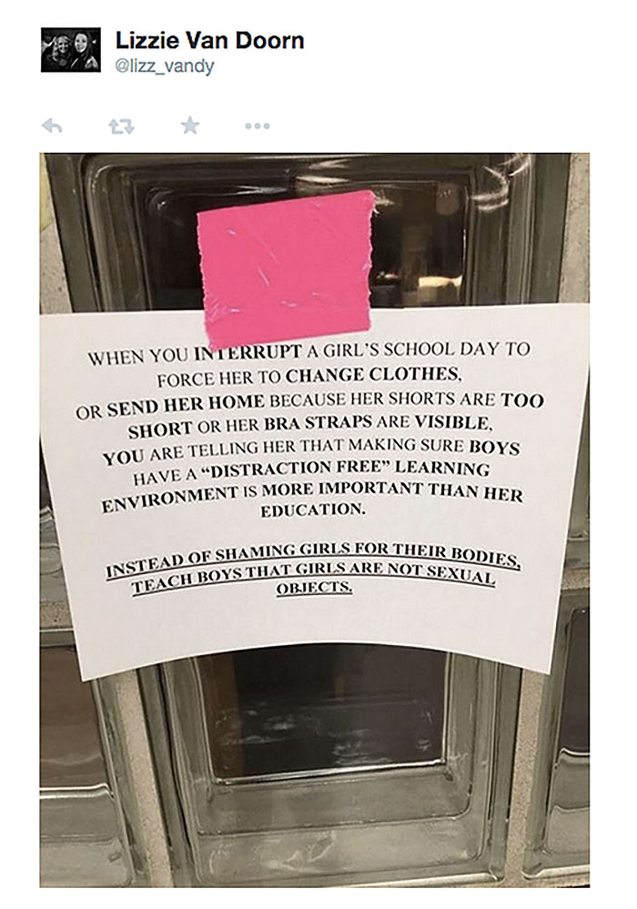
I'm all for teaching kids how to dress appropriately for the classroom, but too often it seems that dress code violations and how they're handled are awfully gender-biased. As this sign points out, it's important to consider the message we're sending to students when enforcing these rules.
Now don't get me wrong — there are definitely some outfits that aren't appropriate for school. But what's telling is how some schools are choosing to enforce their dress code policies for girls — many opting to require dress code violators to wear oversized shirts as punishment. One Florida school has even gone so far as to have students wear a yellow "dress code violation" shirt and sweatpants if they break dress code. Personally, I don't think shame is the best educational tool. Not to mention: A giant bright-yellow shirt sounds kinda "distracting"...
Other schools have banned leggings, skinny jeans, and yoga pants. So now it's not just about showing too much skin. Even the shape of a girl's body is "distracting." And if you think about it, not only are these policies unfairly targeted toward girls, they're also demeaning to male students. Yes, boys have sexual urges, but they're not wild animals that need to be locked up for their own safety and the protection of others. Let's give everyone a little more credit here, shall we?
While some students have started petitions and staged demonstrations to protest these strict dress codes, others have turned to social media, using the hashtag #IAmMoreThanADistraction to share their dress code stories and encourage others to think critically about the message these policies send. Yes, students need to dress appropriately for school, but it's important to set and enforce these standards in ways that don't punish female students for their bodies or suggest that the learning environment will be disrupted because of them.

AP Human Geography | Name:

Objective: To effectively annotate the article, concentrating on passages that surprise you and questions that you have
Directions: Read the article, either with a partner or alone. Annotate the article in line with the objective. As always, circle and define unfamiliar vocabulary words.

Objective: Identify the main idea and supporting details in Dress Code article.

7 Steps to the Main Idea

WHO: Important people in this reading. Underline the
Most important person(s).
WHAT: The problem or
situation

WHEN: timeline when
this occurred.

WHERE: What countries
are involved? Where
is this mainly taking
Place?
WHY: Why is this happening here?

HOW: How did this
situation come to be? (overall theme here)

Every Reading has a subject and a main idea.
- SUBJECT: Who or What is being discussed.

- MAIN IDEA: What the author is saying about the subject.

1. A Stated Main Idea can be found within the title, the first sentence or repeated words/phrases.
Stated Main Idea: ______________________________________________________________________________________________________________________________________________________________________________________________________________________________________________________________________________________________________

2. An Implied Main Idea can be found after gathering all of the details from the reading to make an inference.
Implied Main Idea: ______________________________________________________________________________________________________________________________________________________________________________________________________________________________________________________________________________________________________

