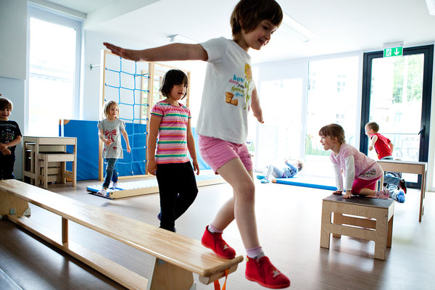
Germany Fights Population Drop
Chris Cottrell contributed reporting from Berlin.
Germany is looking for ways to encourage working mothers. This 24-hour kindergarten, for example, caters to parents who work overnight.

SONNEBERG, Germany — At first glance, this town in central Germany, with rows of large houses built when it was a thriving center of toy manufacturing, looks tidy and prosperous. But Heiko Voigt, the deputy mayor here, can point out dozens of vacant homes that he doubts will ever be sold.

Multimedia
The reality is that the German population is shrinking and towns like this one are working hard to hide the emptiness. Mr. Voigt has already supervised the demolition of 60 houses and 12 apartment blocs, strategically injecting grassy patches into once-dense complexes.
“We are trying to keep the town looking good,” he said.
There is perhaps nowhere better than the German countryside to see the dawning impact of Europe’s plunge in fertility rates over the decades, a problem that has frightening implications for the economy and the psyche of the Continent. In some areas, there are now abundant overgrown yards, boarded-up windows and concerns about sewage systems too empty to work properly. The work force is rapidly graying, and assembly lines are being redesigned to minimize bending and lifting.
In its most recent census, Germany discovered it had lost 1.5 million inhabitants. By 2060, experts say, the country could shrink by an additional 19 percent, to about 66 million.
Demographers say a similar future awaits other European countries, and the issue grows more pressing every day as Europe’s seemingly endless economic troubles accelerate the decline. But bogged down with failed banks and dwindling budgets, few are in any position to do anything about it.
Germany, however, an island of prosperity, is spending heavily to find ways out of the doom-and-gloom predictions, and it would seem ideally placed to show the Continent the way. So far, though, even while spending $265 billion a year on family subsidies, Germany has proved only how hard it can be. That is in part because the solution lies in remaking values, customs and attitudes in a country that has a troubled history with accepting immigrants and where working women with children are still tagged with the label “raven mothers,” implying neglectfulness.
If Germany is to avoid a major labor shortage, experts say, it will have to find ways to keep older workers in their jobs, after decades of pushing them toward early retirement, and it will have to attract immigrants and make them feel welcome enough to make a life here. It will also need to get more women into the work force while at the same time encouraging them to have more children, a difficult change for a country that has long glorified stay-at-home mothers.
There is little doubt about the urgency of the crisis for Europe. Several recent studies show that historically high unemployment rates — in excess of 50 percent among youths — in countries like Greece, Italy and Spain are further discouraging young people from having children. According to the European Union, the total number of live births in 31 European countries fell by 3.5 percent, to 5.4 million from 5.6 million, between 2008 and 2011. In 1960 about 7.5 million children were born in 27 European countries.
Even before those trends were detected, many countries in Europe were expected to shrink by 2060; some, like Latvia and Bulgaria, even more than Germany. And the proportion of elderly will become burdensome. There are about four workers for every pensioner in the European Union. By 2060, the average will drop to two, according to the European Union’s 2012 report on aging.
Some experts worry that Germany has already waited too long to tackle the issue. But others say that is too pessimistic. In any case, in Germany the issue is front and center now.
Large families began to go out of fashion in what was then West Germany in the 1970s, when the country prospered and the fertility rate began dropping to about 1.4 children per woman and then pretty much stayed there, far below the rate of 2.1 children that keeps a population stable. Other countries followed, but not all. There is a band of fertility in Europe, stretching from France to Britain and the Scandinavian countries, helped along by immigrants and social services that support working women.
Raising fertility levels in Germany has not proved easy. Critics say the country has accomplished very little in throwing money at families in a system of benefits and tax breaks that includes allowances for children and stay-at-home mothers, and a tax break for married couples.
Demographers say that a far better investment would be to support women juggling motherhood and careers by expanding day care and after-school programs. They say recent data show that growth in fertility is more likely to come from them.
“If you look closely at the numbers, what you see is the higher the gender equality, the higher the birthrate,” said Reiner Klingholz of theBerlin Institute for Population and Development.
But undoing years of subsidies for traditional households is difficult. “Touching those is political suicide,” said Michaela Kreyenfeld of theMax Planck Institute for Demographic Research in Rostock, Germany.
In the meantime, mothers trying to work here face obstacles that discourage large families. Though Germany recently enacted a law guaranteeing day care for all children over 12 months, compared with 3 years and older before, experts say there is still a shortage of affordable facilities. Further, many schools let out at noon, and there are few after-school programs.
Melanie Vogel, 39, of Bonn, found that trying to blend work and motherhood was so lonely, dispiriting and expensive that she decided to have one child. None of her friends worked full time, her mother-in-law made clear she disapproved, and so did clients in the job fair company she runs with her husband.
“Before my son was born, I was Melanie, a working businesswoman,” Mrs. Vogel said. “But after my son was born, to a lot of people, I was just a mother.”
Many working mothers find themselves quickly pushed into poorly paid “mini” jobs — perhaps 17 hours a week for about $600 a month. More than four million working women in Germany, about a quarter of the female work force, hold such jobs.
Another way to adjust to the population decline is to get older workers to postpone retirement. The German government is raising the retirement age incrementally to 67 from 65, and companies have moved fast to adapt. The share of people ages 55 to 64 in the work force had risen to 61.5 percent in 2012, from 38.9 percent in 2002.
Volkswagen has redesigned its assembly line to ease the bending and overhead work that put excessive strain on workers’ bodies. About three years ago, they began using reclining swivel seats that provide back support even for hard-to-reach spots in the automobiles they are building, and the installation of heavy parts like wheels and front ends is now often fully automated.
Other companies are offering flexible hours to appeal to older workers. Hans Driescher, a physicist trained in the former East, is 74 and still on the job at the German Aerospace Center almost a decade after he reached the mandatory retirement age. He started out working 55 hours a month, but has now cut down to 24. He spends the summer in his garden and works the rest of the year.
With high unemployment rates across most of Southern and Eastern Europe, Germany is in a good position to increase its labor pool by plucking the best and the brightest from its neighbors, and it has begun to do so.
Yet, with hundreds of thousands of skilled jobs unfilled, some executives believe Germany should change its immigration laws and accept foreign credentials to compete for workers with other aging countries.
Germany’s experience with integrating foreign workers in the past, particularly the country’s large Turkish minority, has proved difficult, and many government officials and business leaders are examining Germany’s culture, eager to do what it takes to be hospitable.
But whether they will succeed is unclear. A recent study found that more than half the Greeks and Spaniards who came to Germany left within a year. Many arrivals are young and highly qualified and see a global market for their skills. And many, given the opportunity, will probably go home, experts say. Immigration in general has become more temporary, and moving across borders in Europe is especially easy.
“I think the answer is that we need to look outside Europe,” Dr. Klingholz said.

