GROWING UPSIDE DOWN
By Fernando Molina Cortés
In small-town Peru, Juan Huachaca rises before dawn and works until dusk, hauling mud and building bricks to support his family. He also occasionally attends third grade.
http://narrative.ly/patchwork-of-poverty/growing-upside-down/
Monday, Dec 16, 2013

Imgine the world upside down. Imagine tomorrow morning, you’re getting your son or daughter ready for school. All of a sudden you notice that your progeny isn’t carrying a backpack; he or she is carrying a steel pickax and shovel. Not a toy one for the beach, but a real one, the heavy kind that put blisters on their fingers. When you’re about to help them cross the road you see the track lines on their hands from hours working in the sun. You can’t believe it when you hear “I’m going to work” come out their mouth, with the authoritative tone of a ten-year-old who is used to bringing home the family’s daily bread. This is the other side of the looking glass.
The “other side,” that is, depending on which side you’re on. To Juan Huachaca, a ten-year-old Peruvian boy who works making bricks in Huachipa, a town on the outskirts of Lima, there’s nothing strange about it.
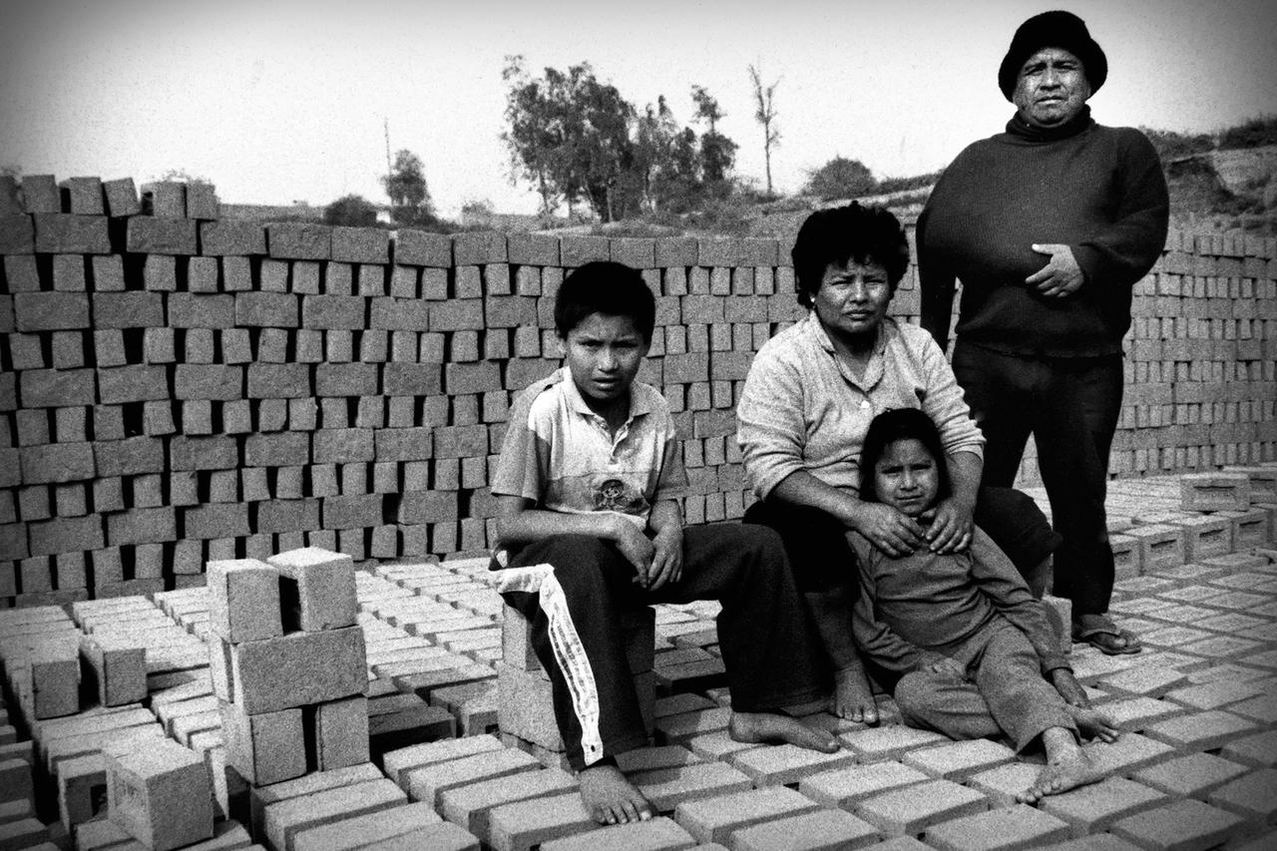Juan Huachaca's family, all of whom work at the brick factory.
“This is where I live, this is where I work,” Juan tells me with a tired voice as he incessantly uses his bare feet to knead an amalgam of clay and water. He lives with his family in an adobe tin-plate house, with mats for flooring, just one bed to share, warmed by a tiny kerosene heater. Cheerful melodies playing in the background are at times able to lift the sordid sadness of poverty.
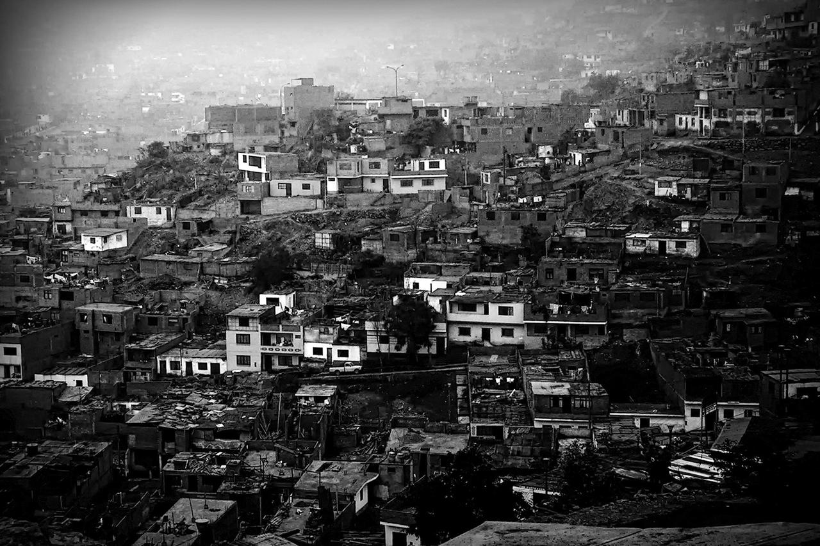Houses for migrants from rural areas of Peru are installed urgently and precariously on the outskirts of Lima.
In Huachipa, the other side of the looking glass, there are no farms, but that doesn’t prevent eighty-five percent of the children here from “working the land,” which is how they refer to traditional brick manufacturing. Once, this land was right-side up, and Juan’s ancestors did work the land with their crops. They sowed corn, potatoes and cotton. The Huaycoloro River even ran through here. Now Huachipa is a wasteland where a few trees barely cling to life, gazing imploringly up, praying to a dry sky always empty of birds and clouds. The only thing growing is the mud that will become the bricks that eat the plain’s skin right off.
Juan gets up at three a.m. and starts work at four, when the world outside is still a sea of dust lit up by the moon and the air comes cold as steel. It’s time for him and his dad to prepare the clay with soil stolen from the plain and water sucked out of a well. They have to do this at night so the blaze of the day doesn’t dry out the mixture.
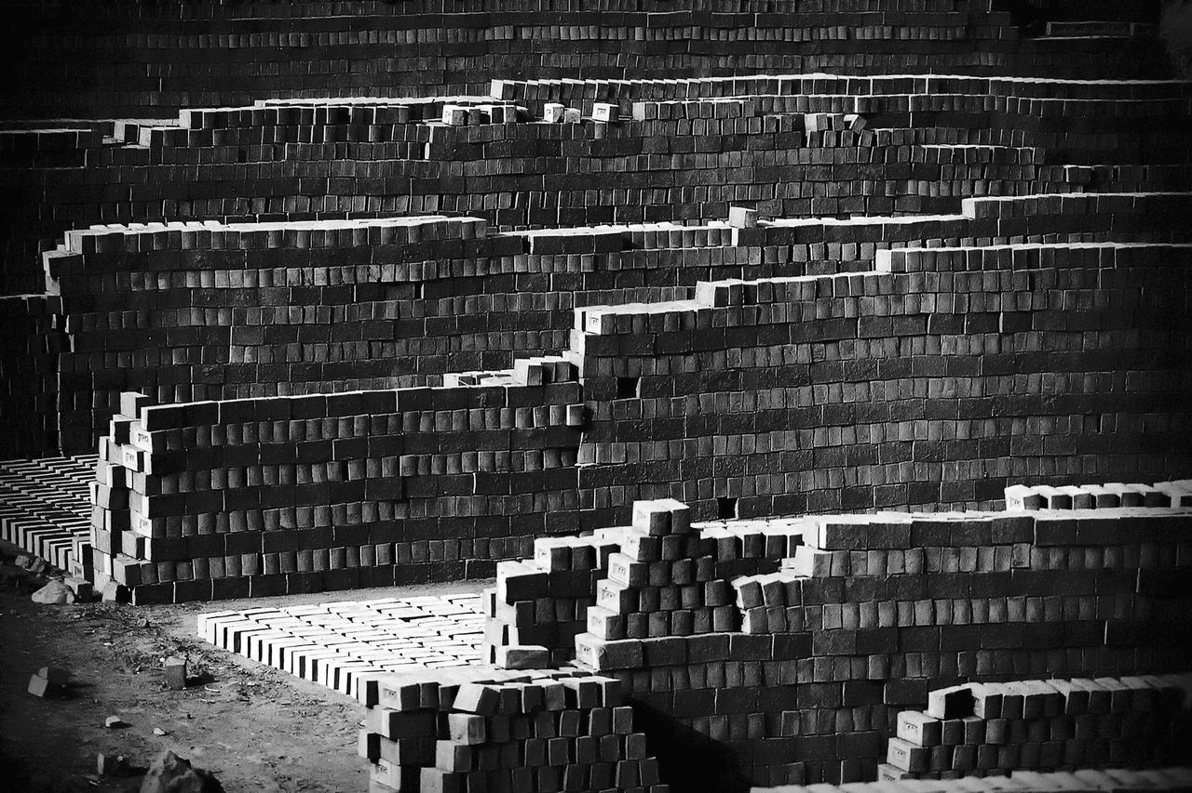Numerous brick factories lie on the pampas of Huachipa. Thousands of families newly arrived in the capital work there.
Later, Juan will go for hours in something close to silence, hauling the mud in a repetitive mechanical method. Between grunts he’ll put the wet substance in the gavera, a kind of mold for four bricks, which will form each piece. He’ll pick up a stick with those crumbly fingers of his and he’ll shave off the extra clay. Then he’ll tip over the thirty-pound mold onto the ground. After that, it’s the sun’s turn to work, drying out the last drop of sweat from the thousands of bricks laid out on the pampas.
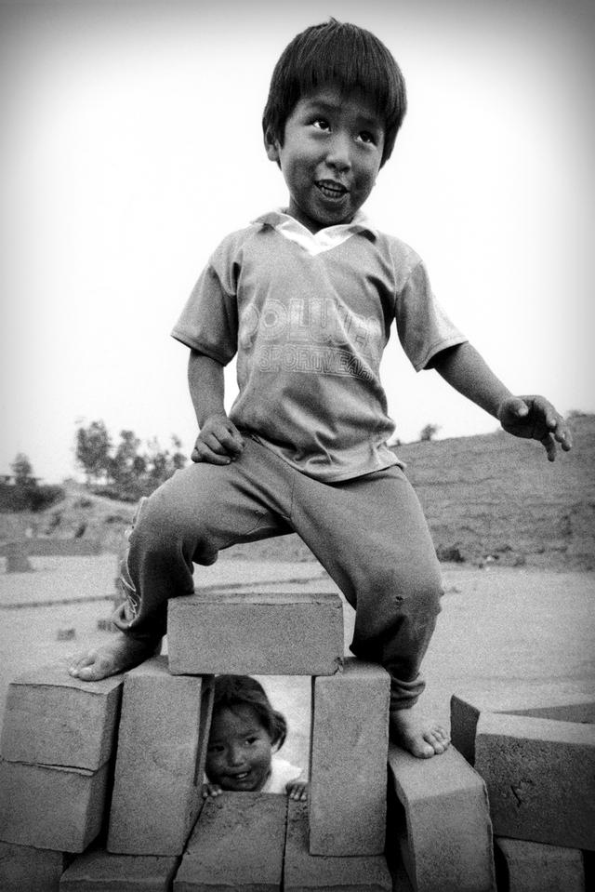Juan Huachaca's little brother and sister. They are just starting to help the family in the brick factory.
Working is normal in Peru for more than two million boys and girls aged five to seventeen—more than one out of every four children here, the second highest child labor rate in Latin America, after Brazil. Developers pay families like Juan’s thirty-two soles (around $13) to “harvest” 1,000 pieces a day. If they don’t hit that number, they don’t get paid, which means everyone in the family has to chip in, even the littlest members of his family, ages three and five. At ten, Juan already knows that his work is a major contributor to helping his family make ends meet. But he complains because “my hands are always cracked. I don’t like anyone seeing them. I’ve got calluses here, here, and here,” he whispers, showing me the insides of his hands.
“My dad showed me how to haul bricks when I was six,” Juan continues, reminiscing about the early stages of his trade. “In the beginning I only worked a little bit, but when I got used to it I could do more and more.” The first day he went to work he was excited, filled with the childlike sensation of growing up all at once. But his childhood never came back.
When the clock strikes eight a.m., Juan has already been working for hours in the holes in the ground. It’s time for school, although he doesn’t always go. When he does attend, he only goes until noon so he can return to the bricks in the afternoon.
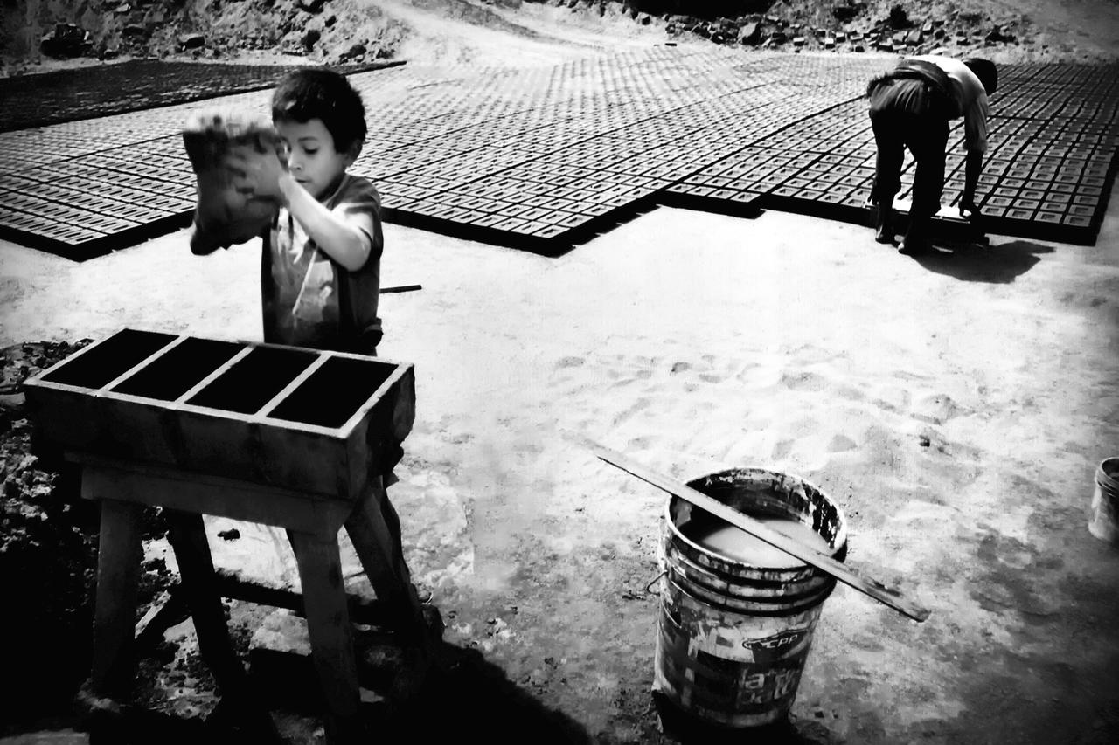A child working with his father in a brick factory in Huachipa.
Working the bricks is, due to its specific characteristics, a job that highly values a child’s qualities like lightness and agility—qualities that make turning the bricks upside down to dry on the other side easy for them. Hiring a child is also “advantageous” for the businessman: It’s always assumed they’ll be paid less than an adult; they don’t usually know their rights; they’re more docile; and they don’t often join unions. Children, it would seem, are clay that can be molded to an employer’s pleasure.
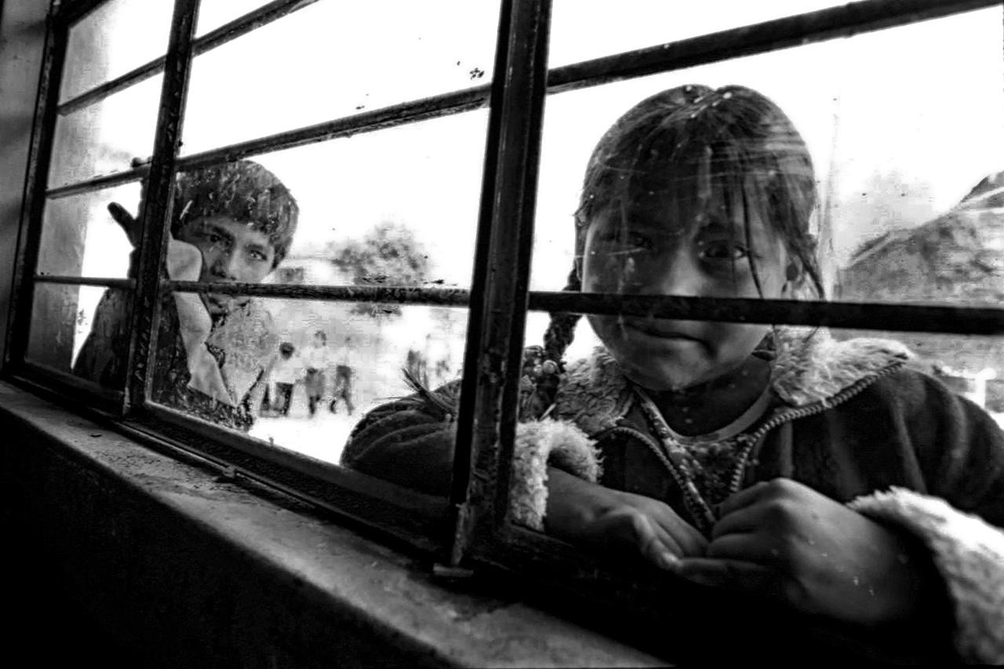A girl and a boy outside the Association for the Defence of Life (ADEVI) school, which helps 100 children a year go to school.
The “advantages” for the kids are also apparent: bone deformities, skeletal muscle problems from repetitive movements, blistered hands and foot injuries. Alfredo Robles, director of Peru’s Life Defense Association, said that these kids usually also “are much shorter than others in their age group. They also tend to be withdrawn since they’re forced into responsibilities as they grow up.”
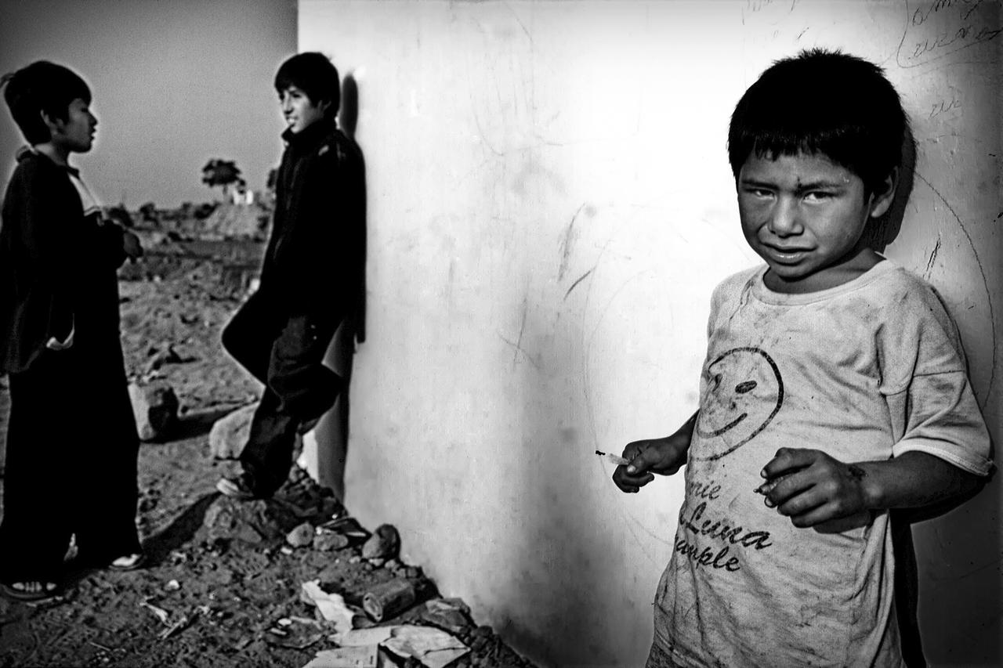Several children hanging out during a break outside the ADEVI classroom in Huachipa.
Yesterday was Sunday, the day of rest, and the kids spent it playing soccer. Juan likes being the goalkeeper. “The goalie has to block the ball,” he says excitedly before the game. “If you don’t see the ball, they can score a goal. I keep my eye on the ball.” The dogs and chickens haven’t even gotten off the field when the ball starts rolling. Juan plays barefoot, with a pair of old sneakers substituting for gloves. He puts the ball into play, kicking it with the tip of his foot. Minutes later, he’s screaming in pain: His big toe is bleeding because he broke a nail. “Put your shoes on your feet!” I shout over to him. “They’re too small for me,” he responds. “My feet are bigger than they are.”
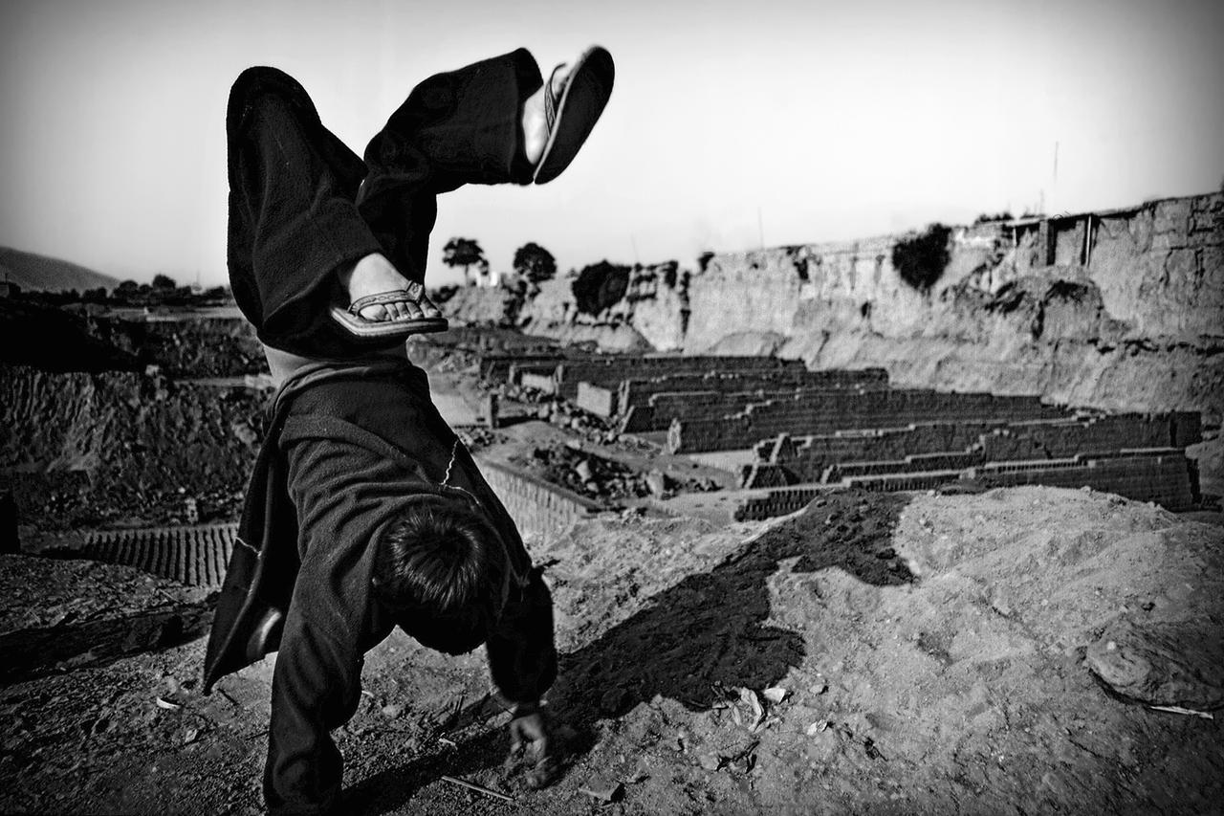Although they barely have free time, children still play.
For these families, economic hardship becomes a vicious circle that repeats with every generation, since work means minors have to stop going to school. That in turn means that when the kids are older they can only work dangerous and unstable jobs. Then the situation repeats itself because their children will also start working when they’re young.
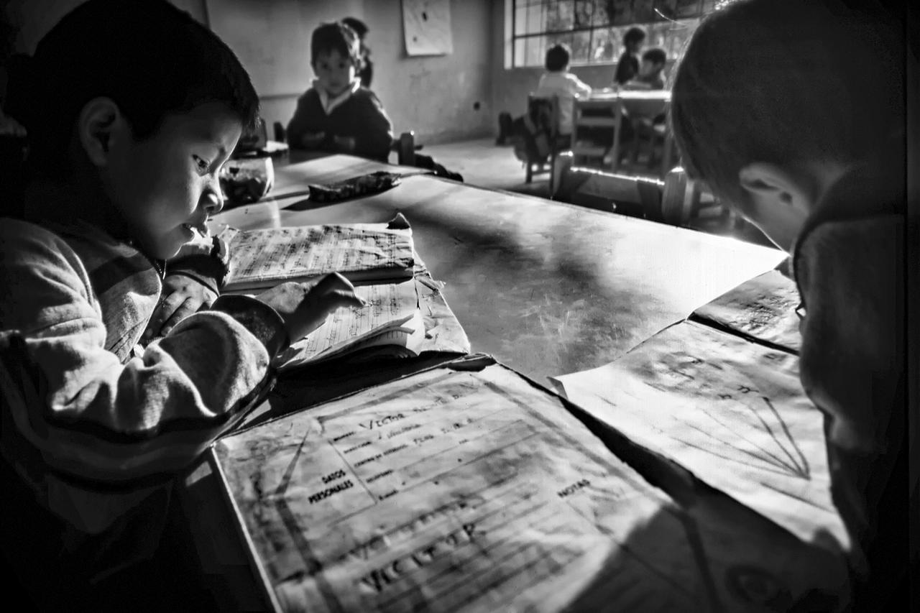Children doing homework inside ADEVI classrooms.
The mud now sleeping in the fields will tomorrow be turned into bricks, destined to be part of a building on any of Lima’s avenues. But, in Huachipa’s upside-down world, the kids aren’t the bricks to build a future society.
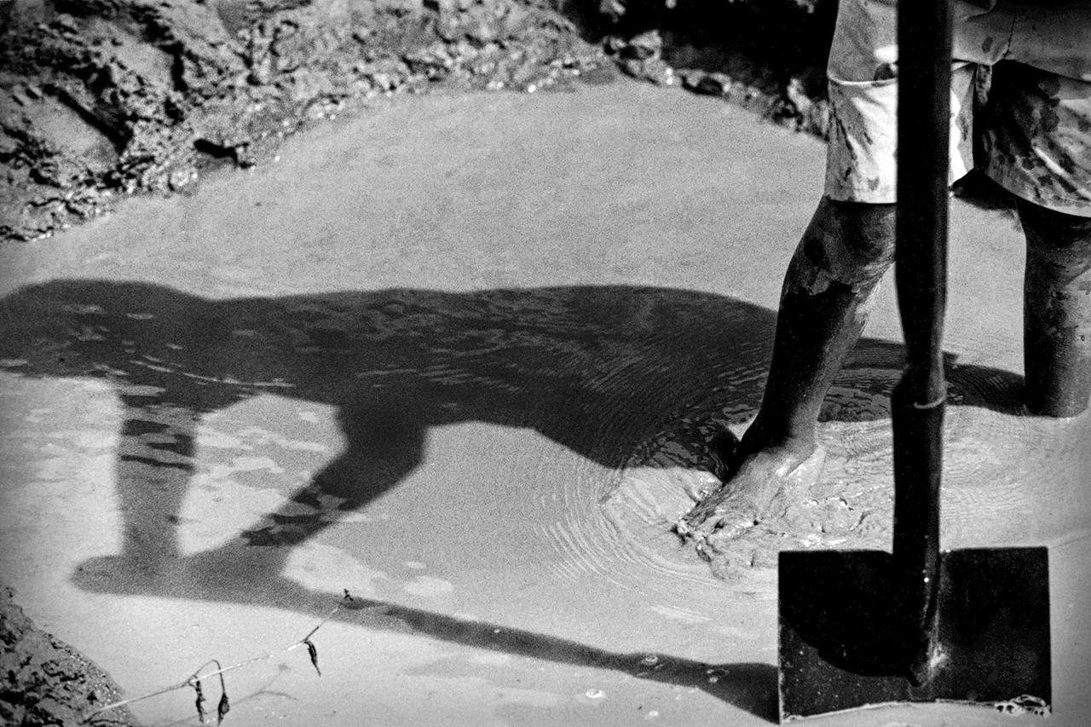Brick is a result of mixing clay and ground water. It is shaped and allowed to dry under the sunshine before being baked.
“What do you do with the bricks once they’re dry?” I ask Juan. He glances at his father, Miguel Huachaca, thirty-nine, who can barely work because he has a broken arm. He looks at me with distrust but he answers, not his son. “It doesn’t totally dry here," he says. "The trucks come and take it to the ovens.”
At the end of the morning, a young man driving a truck filled with bricks actually does appear, the vehicle’s worn-out engine grunting. The trucks are owned by a construction company, a booming industry these past few years.
“What do you want to be when you grow up?” I ask Juan after his father’s interruption.
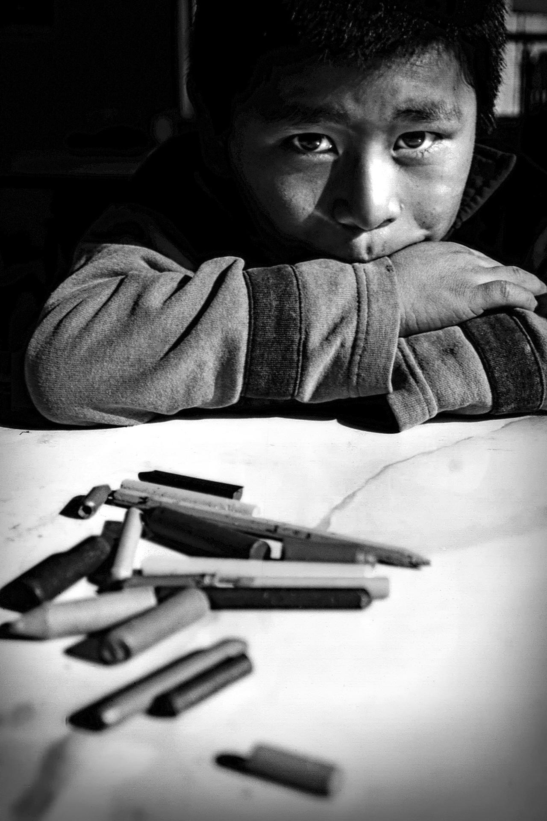Besides homework support, ADEVI programs recreational and artistic activities in order to contribute to integral development.
“I want to be a truck mechanic when I grow up and not keep filling [the brick molds with clay] because it’s messing up my hands and I’m getting scars," he replies.
Juan’s hands are already streaked with time. He’s spent too many summers on a metal seesaw that doesn’t see or saw. He’s flying a clumsy kite that can’t get off the ground because the wind is fickle. Juan is an adult in a child’s body. He’s a kid from the other side.
* * *
Fernando Molina (fermolcor@gmail.com) is a freelance photographer and journalist based in Madrid, Spain. His work has been published by the BBC, Stern, the Toronto Star, Le Soir, and the Hindustan Times, among others.

