Migration Reading Stations-Directions Sheet

With your groups, you will be rotating from station to station today and tomorrow. You will have 20 minutes at each station. Each will have a short article to read, and each will have a reading/writing assignment associated with it. Not everyone will start at “Station One” so make sure you are answering the questions for the correct station! Write your answers on this and a separate sheet of paper. Staple it all together!

Station One: Spain experiencing brain drain as weak economy lingers http://www.usatoday.com/story/news/world/2013/10/26/spain-brain-drain/3015575/
MOW- Meaning of Words
Goal: Use context to determine the appropriate meaning of virtually any word, phrase, or statement in uncomplicated passages
Directions: Answer the question and use the Frayer-Model organizer below to determine the meaning of the term “brain drain” and to think critically about its consequences. Listen for instructions
- What kind of migration is described here? List and explain as many that fit.
- Complete the Frayer-Model below

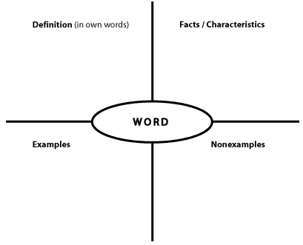
Brain drain
Station Two: Human trafficking-a horrible business http://www.economist.com/node/11561082
Main Idea
Goal: Infer the main idea or purpose of more challenging passages or their paragraphs; Identify a clear main idea or purpose of any paragraph or paragraphs in uncomplicated passages
Directions: Answer the questions below in full and complete sentences on a separate sheet of paper.
- What kind of migration is described here? List and explain as many that fit.
- What is the main idea of the second paragraph? (You can use a direct quote if you like)
- What is the main idea of paragraphs 6-9?
- Using 30 words or less, summarize the main idea(s) of this article.

Station Three: A Great Migration-Spain needs its young people to create new business- http://www.economist.com/news/finance-and-economics/21578702-spain-needs-its-young-people-create-new-businesses-great-migration
REL-sequential relationships
Goal: Identify clear relationships between people, ideas, and so on in uncomplicated passages; Identify clear cause-effect relationships in uncomplicated passages
Directions: read the article and answer the questions that follow on a separate sheet of paper.
- What kind of migration is described here? List and explain as many that fit.
- “The flow has turned from net immigration to net emigration.” Why has Spanish population been falling? Describe the factors and people involved.
- How might language be involved in this population shift? (cause/effect)
- Why does a country need young people? Why does SPAIN need young people?
- “America in the early 20th century was a land of opportunity; that was why immigrants arrived and why they helped the economy to flourish.” What is the author suggesting about Spain? Explain this comparison.

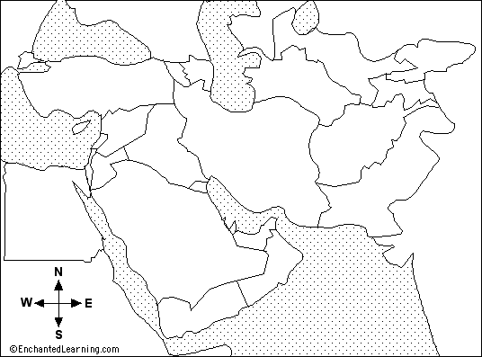
Station Four: Syrian refugees: Living in limbo http://www.economist.com/blogs/pomegranate/2013/07/syrian-refugees
Supporting Details
Goal: Locate important details in more challenging passages, Locate and interpret minor or subtly stated details in more challenging passages
- What kind of migration is described here? List and explain as many that fit.
- Why was the word on the sign switched from “refugee” to “visitor”
- Why have the number of refugees soared in the past 2 years?
- Explain how Egypt has acted against the Status of Refugees treaty.
- LABEL the map with the following countries and: Syria, Egypt, Iran, Iraq, Turkey, Jordan, Lebanon. Color in Syria in yellow, then color any countries in countries that have allowed Syrian refugees in green, countries that haven’t in red, and countries that have limitations in orange.
- Why are Syrians facing growing hostilities in their host countries?

http://www.iza.org/conference_files/LeIlli2010/trebesch_c4269.pdf
http://www.solidaritycenter.org/files/migration_factsheet3.pdf
http://www.economist.com/news/finance-and-economics/21578702-spain-needs-its-young-people-create-new-businesses-great-migration
http://www.economist.com/node/18741382
http://www.economist.com/news/books-and-arts/21586813-costs-and-benefits-mass-immigration-mobile-masses
https://www.amherst.edu/media/view/247221/original/Economics%2Bof%2BHuman%2BTrafficking.pdf
http://www.economist.com/node/11561082

http://www.readingquest.org/strat/home.html

