EFFECTS OF HURRICANE KATRINA IN NEW ORLEANS
As the center of Hurricane Katrina passed southeast of New Orleans on August 29, 2005, winds downtown were in the Category 3 range with frequent intense gusts and tidal surge. Hurricane-force winds were experienced throughout the city, although the most severe portion of Katrina missed the city, hitting nearby St. Bernard and Plaquemines parishes. Hurricane Katrina made its final landfall in eastern St. Tammany Parish. The western eye wall passed directly over St. Tammany Parish, Louisiana as a Category 3 hurricane at about 9:45 am CST, August 29, 2005.[1] The communities of Slidell, Louisiana, Avery Estates, Lakeshore Estates, Oak Harbor, Eden Isles and Northshore Beach were inundated by the storm surge that extended over six miles inland. The storm surge affected all 57 miles (92 km) of St. Tammany Parish’s coastline, including Lacombe, Mandeville and Madisonville.[2] The storm surge in the area of the Rigolets Pass was estimated to be 16 feet, not including wave action, declining to 7 feet (2.1 m) at Madisonville. The surge had a second peak in eastern St. Tammany as the westerly winds from the southern eye wall pushed the surge to the east, backing up at the bottleneck of the Rigolets Pass.
In the City of New Orleans, the storm surge caused more than 50 breaches in drainage canal levees and also in navigational canal levees and precipitated the worst engineering disaster in the history of the United States.[3] By August 31, 2005, 80% of New Orleans was flooded, with some parts under 15 feet (4.6 m) of water. The famous French Quarter dodged the massive flooding experienced in other levee areas. Most of the city's levees designed and built by the United States Army Corps of Engineers broke somewhere, including the 17th Street Canal levee, the Industrial Canal levee, and the London Avenue Canal floodwall. These breaches were responsible for most of the flooding, according to a June 2007 report by the American Society of Civil Engineers.[4] Oil refining was stopped in the area, increasing oil prices worldwide.
Between 80 and 90 percent of the residents of New Orleans were evacuated safely in time before the hurricane struck, testifying to some of the success of the evacuation measures.[5] Despite this, many remained in the city, mainly those who did not have access to personal vehicles or who were isolated from the dissemination of news from the local governments. The Louisiana Superdome was used to house and support some of those who were unable to evacuate. Television shots frequently focused on the Superdome as a symbol of the flooding occurring in New Orleans.
The disaster had major implications for a large segment of the population, economy, and politics of the entire United States. It has prompted a Congressional review of the Corps of Engineers and the failure of portions of the federally built flood protection system which experts agree should have protected the city's inhabitants from Katrina's surge. Katrina has also stimulated significant research in the academic community into urban planning, real estate finance, and economic issues in the wake of a natural disaster.[6] As the center of Hurricane Katrina passed southeast of New Orleans on August 29, 2005, winds downtown were in the Category 3 range with frequent intense gusts and tidal surge. Hurricane-force winds were experienced throughout the city, although the most severe portion of Katrina missed the city, hitting nearby St. Bernard and Plaquemines parishes. Hurricane Katrina made its final landfall in eastern St. Tammany Parish. The western eye wall passed directly over St. Tammany Parish, Louisiana as a Category 3 hurricane at about 9:45 am CST, August 29, 2005.[1] The communities of Slidell, Louisiana, Avery Estates, Lakeshore Estates, Oak Harbor, Eden Isles and Northshore Beach were inundated by the storm surge that extended over six miles inland. The storm surge affected all 57 miles (92 km) of St. Tammany Parish’s coastline, including Lacombe, Mandeville and Madisonville.[2] The storm surge in the area of the Rigolets Pass was estimated to be 16 feet, not including wave action, declining to 7 feet (2.1 m) at Madisonville. The surge had a second peak in eastern St. Tammany as the westerly winds from the southern eye wall pushed the surge to the east, backing up at the bottleneck of the Rigolets Pass.
In the City of New Orleans, the storm surge caused more than 50 breaches in drainage canal levees and also in navigational canal levees and precipitated the worst engineering disaster in the history of the United States.[3] By August 31, 2005, 80% of New Orleans was flooded, with some parts under 15 feet (4.6 m) of water. The famous French Quarter dodged the massive flooding experienced in other levee areas. Most of the city's levees designed and built by the United States Army Corps of Engineers broke somewhere, including the 17th Street Canal levee, the Industrial Canal levee, and the London Avenue Canal floodwall. These breaches were responsible for most of the flooding, according to a June 2007 report by the American Society of Civil Engineers.[4] Oil refining was stopped in the area, increasing oil prices worldwide.
Between 80 and 90 percent of the residents of New Orleans were evacuated safely in time before the hurricane struck, testifying to some of the success of the evacuation measures.[5] Despite this, many remained in the city, mainly those who did not have access to personal vehicles or who were isolated from the dissemination of news from the local governments. The Louisiana Superdome was used to house and support some of those who were unable to evacuate. Television shots frequently focused on the Superdome as a symbol of the flooding occurring in New Orleans.
The disaster had major implications for a large segment of the population, economy, and politics of the entire United States. It has prompted a Congressional review of the Corps of Engineers and the failure of portions of the federally built flood protection system which experts agree should have protected the city's inhabitants from Katrina's surge. Katrina has also stimulated significant research in the academic community into urban planning, real estate finance, and economic issues in the wake of a natural disaster.[6]
Architecture & Culture Of New Orleans
ARCHITECTURAL VIGNETTES
New Orleans, with its richly mottled old buildings, its sly, sophisticated - sometimes almost disreputable - air, and its Hispanic-Gallic traditions, has more the flavor of an old European capital than an American city. Townhouses in the French Quarter, with their courtyards and carriageways, are thought by some scholars to be related on a small scale to certain Parisian "hotels" - princely urban residences of the 17th and 18th centuries. Visitors particularly remember the decorative cast-iron balconies that cover many of these townhouses like ornamental filigree cages.
European influence is also seen in the city's famous above-ground cemeteries. The practice of interring people in large, richly adorned aboveground tombs dates from the period when New Orleans was under Spanish rule. These hugely popular "cities of the dead" have been and continue to be an item of great interest to visitors. Mark Twain, noting that New Orleanians did not have conventional below-ground burials, quipped that "few of the living complain and none of the other."
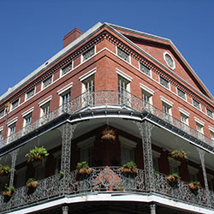
One of the truly amazing aspects of New Orleans architecture is the sheer number of historic homes and buildings per square mile. Orleanians never seem to replace anything. Consider this: Uptown, the City's largest historic district, has almost 11,000 buildings, 82 percent of which were built before 1935 - truly a "time warp."
The spine of Uptown, and much of New Orleans, is the city's grand residential showcase, St. Charles Avenue, which the novel A Confederacy of Dunces aptly describes: "The ancient oaks of St. Charles Avenue arched over the avenue like a canopy...St. Charles Avenue must be the loveliest place in the world. From time to time...passed the slowing rocking streetcars that seemed to be leisurely moving toward no special designations, following their route through the old mansions on either side...everything looked so calm, so prosperous."
The streetcars in question, the St. Charles Avenue line, represent the nation's only surviving historic streetcar system. All of its electric cars were manufactured by the Perley Thomas Company between 1922 and 1924 and are still in use. Hurricane Katrina flood waters caused severe damage to the steel tracks along the entire uptown and Carrollton route and had to be totally replaced and re-electrified. The cars themselves survived and are included in the National Register of Historic Places. New Orleanians revere them as a national treasure.
UNIQUE HOUSING FOR A UNIQUE CITY
Creole cottages and shotgun houses dominate the scene in many New Orleans neighborhoods. Both have a murky ancestry. The Creole cottage, two rooms wide and two or more deep under a generous pitched roof with a front overhang or gallery, is thought to have evolved from various European and Caribbean forms.
The shotgun house is one room wide and two, three or four rooms deep, under a continuous gable roof. As legend has it, the name was suggested by the fact that because the rooms and doors line up, one can fire a shotgun through the house without hitting anything.
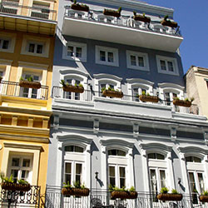Some scholars have suggested that shotguns evolved from ancient African "long-houses," built here by refugees from the Haitian Revolution, but no one really knows.
It is true that shotguns represent a distinctively Southern house type. They are also found in the form of plantation quarters houses. Unlike shotgun houses in much of the South, which are fairly plain, New Orleans shotguns fairly bristle with Victorian jigsaw ornament, especially prominent, florid brackets. Indeed, in many ways, New Orleans shotguns are as much a signature of the city as the French Quarter.
New Orleans' architectural character is unlike that of any other American city. A delight to both natives and visitors, it presents such a variety that even after many years of study, one can still find things unique and undiscovered.
This material may be reproduced for editorial purposes of promoting New Orleans. Please attribute stories to New Orleans Metropolitan Convention and Visitors Bureau. 2020 St. Charles Avenue, New Orleans, LA 70130 504-566-5019. http://www.neworleanscvb.com/.
New Orleans: Clicking Snapshots of a Unique Culture
Posted on June 11, 2013
New Orleans’ culture is rich and multi-layered like a complex and very refined cake. While on tour with the wonderful BlogtourNOLA gang, I snapped a few images of some of what makes this city’s heart beat faster.
The food:
The food is to die for and -literally- has visitors commenting out loud with their mouths full: “I’ll diet as soon as I get back home!”
The music:
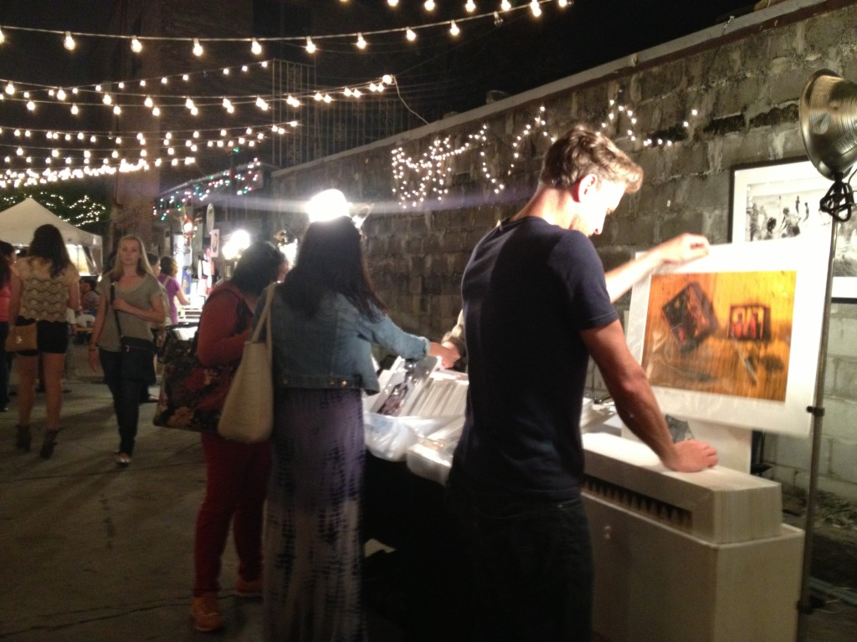
At the Frenchmen Art Market. Photo Barbara Elza Hirsch | Chez Elza

