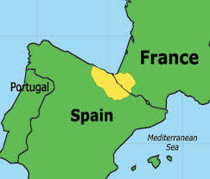
Basque Country

Location

Euskal Herria, Euskadi, or Basque Country are the names most commonly used to refer to the people
located on the shores of the Bay of Biscay and on the two sides of the western Pyrenees that separate
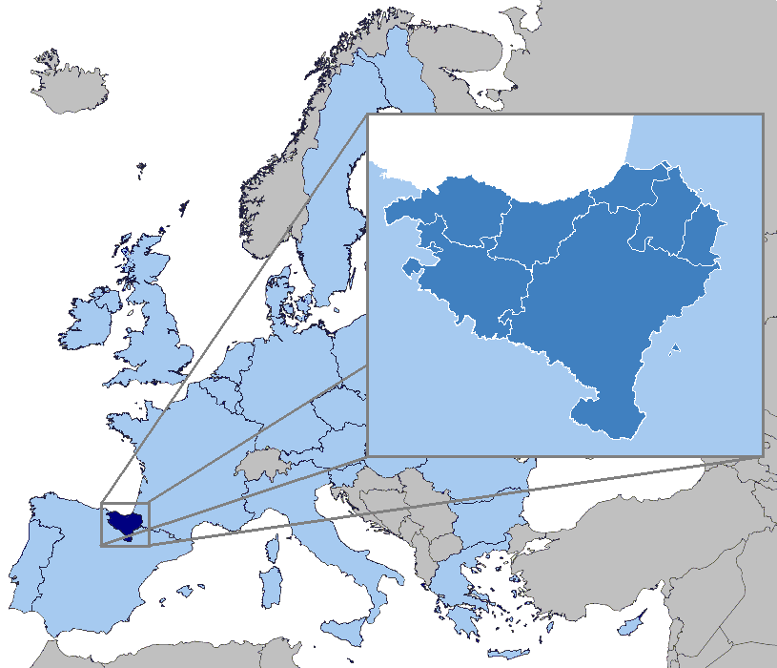
the Spanish and French States. At present, what has been historically and culturally called the Basque Country is divided among three political-administrative structures:
In the French State, le Pays Basque,
and within the Spanish State, the Basque Autonomous Community and the Autonomous Community of Navarra. The southern part of the Basque Country, located to the south of the Pyrenees, is part of the Spanish State. The population of these territories is 2,873,512 and they cover 20,644 square kilometres.

The Basque language (Euskera) is one of the oldest pre-Indo-European languages in Europe, and its
origins are still unknown today.

The history
The disagreements have deep historical roots (some historians trace them back to the 15th century).
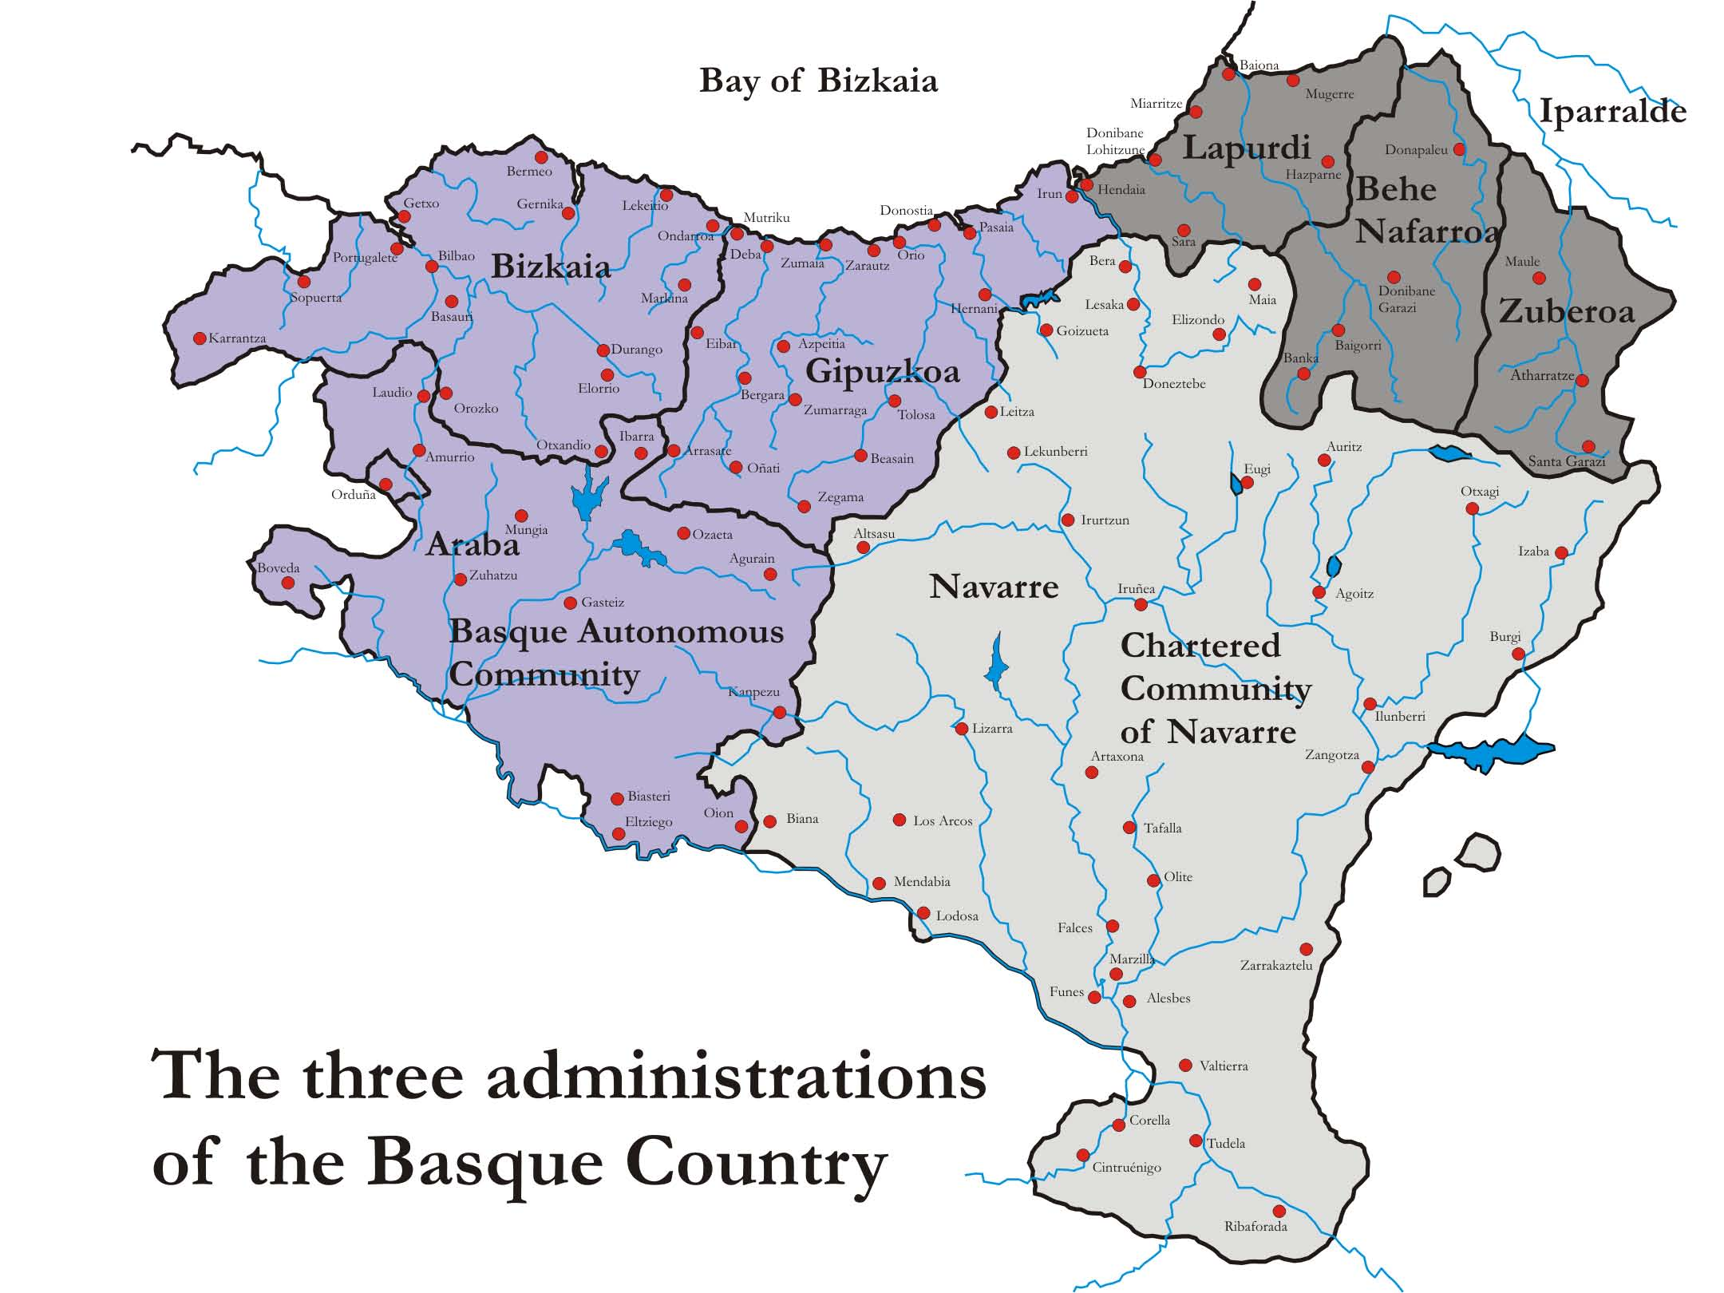
In the Basque provinces, there has traditionally been a tendency to defend a different social reality or
identity, one that includes a different language, a different culture, and different customs. Numerous
conflicts and wars occurred prior to the 19th century because of an annexing or centralizing rationale
of Kingdoms or States that wished to incorporate the Basque provinces into their territory and to
exercise sovereignty over the Basque people. In this context, Basque nationalism emerged as a political
movement a little more than 100 years ago.

Under Franco
In the 20th Century the Fascist dictatorship (1936-1975) considerably aggravated the Basque problem.
It violently suppressed all symbols of Basque identity and all forms of self-government. The dictator
Francisco Franco believed in one unified Spanish state, opposing regional diversity. He banned the use of the Basque language, Euskera, and prohibited various expressions of the Basque culture. In
1958 Basque Homeland and Freedom (Euzkadi Ta Azkatasuna; ETA) was born as a response to this
repression. Franco died in 1975 and the regime gave way to the Monarchy of Juan Carlos I de Borbón.

Democracy
At this time, the Transition process towards democracy began. A new Spanish constitution was
approved in referendum on December 6, 1978, which guaranteed the right to autonomy for the Basque
Country¹s nationalities and regions. A system of self-government was later negotiated for the three
territories that were to become the Autonomous Community of the Basque Country. Some examples of
the powers transferred to the Autonomous Community include: an autonomous police force, the creation
of the Basque radio/TV station, and education and health systems.
Almost 30 years after the Transition’s beginning, two major problems still plague the Basque Country:
persisting violence and deep political disagreements on the framework of relations between the Basque
Country and the Spanish State. After all this time, a basic consensus has still not been reached that could
integrate all the political traditions. This has not been achieved by the Spanish Constitution, the Statutes
of Autonomy, or the various Pacts for the pacification and normalization of co-existence that have been
attempted.

The history and violence of ETA
ETA was formed as a protest against what they considered to be a passive attitude on the part of the
moderate nationalists and against the Franco dictatorship. Its main purpose is to create an independent
Basque state that would incorporate the Pays Basque in France with the Basque territories in Spain.
During the first ten years of ETA’s existence, it limited its activity to propaganda. However, violence,
such as bombs, sabotage, and robbery, slowly became its preferred method for achieving political goals.
The first death resulting from ETA’s actions occurred in 1968 and since then, the violence and deaths
have continued, aimed at targets such as politicians and journalists.
The vast majority of Basque society actively rejects the violence of ETA, while a minority sympathizes
with it, justifying it as an exercise of self-defense. Throughout its history ETA has caused around
a thousand deaths. It has called two major ceasefires: one in 1989 during the failed negotiations in
Algiers with the Socialist government of Spain and in 1998, leading to 14 months of non-violence. In
recent years the violence of ETA has particularly struck hard at non-nationalists, leading to a climate of
extreme political tension.

Basque society

Basque society is diverse in its political identification and in its feelings of belonging to a nation: some
people want a Basque Country independent from Spain, others want to maintain the status quo, and
others would like a framework of self-government that gives the Basque people the capability to decide
their future. All the opinion tolls in the last 10 years, and even the last elections, show that a majority of
the Basque society: (a) firmly rejects violence; (b) considers that there are political problems that must
be solved; (c) is firmly in favor of dialogue; and (d) wants the capability to express its opinion on its
future status.
Kurdistan
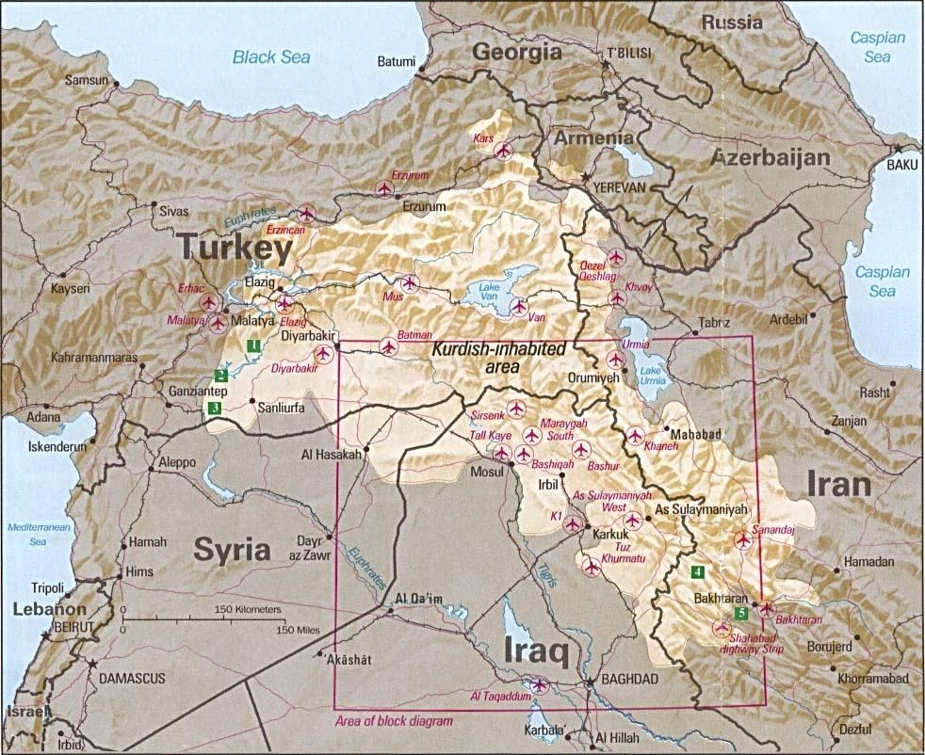
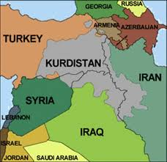
A largely Sunni Muslim people with their own language and culture, most Kurds live in the generally
contiguous areas of Turkey, Iraq, Iran, Armenia and Syria – a mountainous region of southwest Asia
generally known as Kurdistan ("Land of the Kurds").

Before World War I, traditional Kurdish life was nomadic, revolving around sheep and goat herding
throughout the Mesopotamian plains and highlands of Turkey and Iran. The breakup of the Ottoman
Empire after the war created a number of new nation-states, but not a separate Kurdistan. Kurds, no
longer free to roam, were forced to abandon their seasonal migrations and traditional ways.

During the early 20th century, Kurds began to consider the concept of nationalism, a notion introduced
by the British amid the division of traditional Kurdistan among neighboring countries. The 1920
Treaty of Sevres, which created the modern states of Iraq, Syria and Kuwait, was to have included the
possibility of a Kurdish state in the region. However, it was never implemented. After the overthrow
of the Turkish monarchy by Kemal Ataturk, Turkey, Iran and Iraq each agreed not to recognize an
independent Kurdish state.

The Kurds received especially harsh treatment at the hands of the Turkish government, which tried to deprive them of Kurdish identity by designating them "Mountain Turks," outlawing their language and forbidding them to wear traditional Kurdish costumes in the cities. The government also encouraged the migration of Kurds to the cities to dilute the population in the uplands. Turkey continues its policy of not recognizing the Kurds as a minority group.

In Iraq, Kurds have faced similar repression. After the Kurds supported Iran in the 1980-88 Iran-Iraq war, Saddam Hussein retaliated, razing villages and attacking peasants with chemical weapons. The
Kurds rebelled again after the Persian Gulf War only to be crushed again by Iraqi troops. About 2 million fled to Iran; 5 million currently live in Iraq. The United States has tried to create a safe haven for the Kurds within Iraq by imposing a "no-fly" zone north of the 36th parallel.

Despite a common goal of independent statehood, the 20 million or so Kurds in the various countries
are hardly unified. From 1994-98, two Iraqi Kurd factions – the Kurdistan Democratic Party, led by
Massoud Barzani, and the Patriotic Union of Kurdistan, led by Jalal Talabani – fought a bloody war for
power over northern Iraq. In September 1998, the two sides agreed to a power-sharing arrangement.

Meanwhile, the Kurdistan Workers' Party, the PKK, currently waging a guerrilla insurgency in
southeastern Turkey, has rejected the Iraqi Kurds' decision to seek local self-government within a
federal Iraq. The PKK believes any independent Kurdish state should be a homeland for all Kurds.

Over the years, tensions have flared between the PKK, led by Abdullah Ocalan, and Barzani's KDP
faction, which controls the Turkey-Iraq border. Barzani has criticized the PKK for establishing military
bases inside Iraqi-Kurd territory to launch attacks into Turkey.

At least in the short term, Iraq's Kurds seem willing to join in the formulation of the postwar government
of Iraq. Kurds participated fully in the legislative assembly election in early 2005 and won 28% of the
seats. There was immediate tension with the majority Shiite Muslim bloc, however, over whether the
Kurds would have regional autonomy or be fully subject to Baghdad's control. Perhaps the clearest sign
of the Kurds' long-term aspiration was the result of an informal referendum held in conjunction with the
parliamentary election. Fully 98% of all Kurds voted for eventual independence. "The fact remains that
we are two different nationalities in Iraq—we are Kurds and Arabs," one Kurdish leader noted.(2) But
the national, regional and global implications of an independent Kurdistan in Northern Iraq can not be
overstated and must continue to be a focus of the international community.

(from http://www.washingtonpost.com/wp-srv/inatl/daily/feb99/kurdprofile.htm)
Following the collapse of the world's great empires and the birth of a whole slew of new nations from
Eastern Europe to the Middle East, it's fair to say the Kurds got a raw deal. Their homeland was carved
up by the borders of Iran, Syria, Iraq and Turkey. To this day, the majority of the world's Kurdish
population (some 30 million) live in this contiguous territory as ethnic minorities in other nations.

In a bid to subdue Kurdish identity, Turkey's founders deemed Kurds "mountain Turks" and forbade the
use of the Kurdish language until 1991. An outlawed Kurdish guerrilla group, the Kurdistan Workers'
Party or the PKK, waged a high-profile insurgency starting in the 1970s that led to over 30,000 deaths in
Turkey. Hostilities have died down in recent years, though tensions remain. Kurds have fared somewhat
better in neighboring Iraq. Following the 2003 U.S. invasion of Iraq, Iraqi Kurdistan in the north —
which already had de facto autonomy from Baghdad ever since the end of the 1991 Gulf War — has
seen relative stability and an economic boom. Much to the chagrin perhaps of dyed-in-the-wool Kurdish
nationalists, the biggest economic sponsor in the region is currently Turkey.

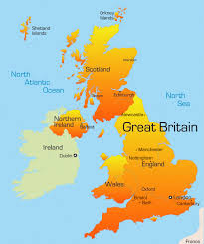
(http://www.time.com/time/specials/packages/article/0,28804,2041365_2041364_2041453,00.html)
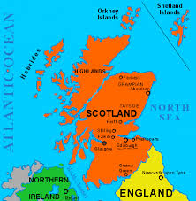
Scotland

Scotland has been formally joined with England since 1707, when the two nations dissolved their
parliaments and united to form Great Britain. Yet despite centuries of being under London's yoke,
Scotland still considers itself a separate country and periodically pushes for independence.

The Scottish National Party (SNP), which supports full independence from Britain, formed in 1934 and won its first British parliamentary seat in 1945. In 1999, Scotland elected its first Parliament in nearly 300 years (though Queen Elizabeth II formally began the opening session — maybe to remind them who was boss?). The Scottish Parliament controls domestic policy in Scotland, while Westminster still handles everything else. Because of this, Scotland could ban smoking when the rest of Britain still allowed cigarettes in public places. The SNP won the nation's 2007 parliamentary elections and has periodically urged Scotland to take up a referendum on independence ever since. Even if passed, the referendum would not be binding unless approved by the British Parliament.

(http://www.time.com/time/specials/packages/article/0,28804,2041365_2041364_2041340,00.html)

Communities split by Scottish independence row

With Scotland heading towards a referendum on becoming an independent state, those living in the
border communities are split over whether - and how - to break away from the rest of the United Kingdom.

Berwick-upon-Tweed is the northernmost town in England and is situated on the eastern coast just four kilometers south of the Scottish border. If Scotland were to become an independent country, the town
would suddenly find itself sitting on a new international frontier. Berwick is no stranger to conflict
of this kind. For centuries, the traditional market town was the subject of a war between England and
Scotland, though the latter has now been in political union with England for nearly 300 years.

But that could change. Earlier this month, First Minister of Scotland and leader of the Scottish National
Party (SNP), Alex Salmond, proposed holding a referendum on Scottish independence in 2014.
Salmond objects to interference in Scottish affairs by the British government led by the center-right

Conservatives, who are unpopular north of the border. British Prime Minister David Cameron, along
with all the main parties in Westminster, wants to keep the United Kingdom intact. Cameron has said
any referendum should be held sooner rather than later to dispel uncertainty he says is damaging the
Scottish economy. Opinion polls show that a binding referendum on independence is likely to be rejected by the Scots, but any delay makes such an outcome less certain.

English indifference

As the row rumbles on between the politicians in Edinburgh and London, the people of Berwick-upon-
Tweed appear to be surprisingly indifferent to the idea of their close neighbor breaking away from the
rest of the UK. Phil Johnson is editor of the local newspaper, The Berwick Advertiser. He points out that while there are close ties between Berwick and Scotland, there are already major differences depending
on which side of the border you live.

"We have a different police force on either side of the border, we have a different education system,
so I don't suppose these kinds of things would change if Scotland was independent," he told Deutsche
Welle. "What might change is that it might be a bit more difficult for businesses." And it's the economy that makes the Scots so uncertain when it comes to the question of total independence.

"At the moment here we get every year an amount of money from Westminster based on fixed
share of the total UK tax take," explained Lesley Riddoch a freelance journalist who writes for The
Scotsman. "So we get slightly more than we are due, because this formula was devised at a time when
our population share was larger, and when it was recognized that we needed more money to deliver public services due to the remoteness of many parts of Scotland." Riddoch said the current system of
Westminster handing Holyrood money to spend was "like a teenager getting pocket money." But she
added, "I think Scots are not confident that we would remain with the same income if we only had us as
a tax base."

Growing support for nationalism

On the Scottish side of the border, in the small town of Galashiels, local journalist, David Knox, says a
lot hangs on the question of oil. An independent Scotland could lay claim to a large proportion of North
Sea oil revenues, which currently flow into the Treasury in London. "Oil seems to be the trump card
that the Scottish parliament holds up every now and again, saying 'if we had our oil money we'd be a
much richer country,'" Knox said. "We do get a lot of subsidies from Westminster, so one perhaps would balance the other."

Knox, who edits the local newspaper The Border Telegraph, has seen growing support for Alex
Salmond and the SNP in the local area. "Since the Scottish parliament was formed [in 1999], there have
been significant changes, mostly for the good. We've seen free prescriptions, free care for the elderly,
lots of good initiatives coming in for care for young children as well pre-school," said Knox. "I think
that has increased support for possibly a stronger independence, I don't know about full independence,
but definitely going down the path there is more and more support for it."

London wants a referendum with a straight yes or no question on independence, which polls suggest
would be rejected. Salmond, meanwhile, is open to having a second question on the ballot, offering
Scottish voters a greater degree of devolution from London. That option is referred to as "devolution
max" and would give the Scottish parliament the power to raise and spend their own taxes, and end their
fiscal relationship with London.

Knox thinks that many in the Scottish borders would vote for that third option, if it were offered on the
ballot paper. "I think there's a move towards a happy medium between full independence and what we
have at the moment. Somewhere in between would satisfy most people," he said.

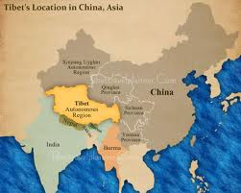
Tibet

Pointing to old imperial records, Beijing claims that Chinese sovereignty over Tibet dates back
centuries, though these claims have been disputed by some historians and Tibetan nationalists. In
1950, Chinese troops invaded the rugged plateau region, overrunning the outmatched Tibetan army
and compelling the then Tibetan government to sign the 17-Point Agreement, which affirmed China's
sovereignty over Tibet while also granting the region a degree of autonomy. Some members of the
Tibetan Cabinet, however, claimed not to have accepted the agreement. A violent crackdown in 1959 on

Tibetan dissidents saw the 14th Dalai Lama of Tibet flee to India and repudiate the document as having
been forced on his people. The Dalai Lama has spent more than half a century since in exile calling on China to grant his homeland greater freedoms.

(Read more: http://www.time.com/time/specials/packages/article/0,28804,2041365_2041364_2041291,00.html #ixzz1kRcRntDy)

Tibetan independence hopes look over after China refuses to budge

The Dalai Lama's hopes of achieving independence for Tibet look to be over after China said that talks
with his envoys had failed and that it will not compromise over its status. Last week's talks came after the Dalai Lama announced that he too had "given up" on the six-year negotiation process between Beijing and Tibet's government-in-exile.

He added, in a visit to Japan two weeks ago that the situation for Tibetans is deteriorating and that Chinese rule is "almost like a death sentence". He said: "My trust in the Chinese government has become thinner, thinner, thinner. I cannot take direct responsibility for dealing with the Chinese government any more. Now it is up to the people."

Lodi Gyaltsen Gyari, Kelsang Gyaltsen, and three aides arrived in Beijing for the third round of talks this year at the end of October. Zhu Weiqun, a spokesman for the Chinese government, blamed the Tibetan envoys for the failure of the talks. "They should assume full responsibility. In our conversations, we pointed out that the unification of the motherland, territorial integrity and national dignity are the greatest interests of the Chinese people. On these fronts we won't make any concessions, at any time and for anyone," he said. He added that the talks had centered on the Dalai Lama. "We merely talked about how the Dalai Lama should completely give up his separatist opinions," he said.

The deputy governor of Tibet, Bai Ma Cai Wang, has admitted that China has recently increased its security forces in the region. "In order for Tibet's stability and for people's safety and for people's desire
for security and order, the Government has moderately adjusted the presence of the police force on the
street," he told The Australian newspaper.

Patrols in Lhasa, the Tibetan capital, have reportedly been reinforced by the presence of snipers on rooftops around the city's holiest site, the Jokhang Temple.

The failure of the talks, and the Dalai Lama's decision not to continue with the negotiation process,
could open the way for a fresh wave of violence in the region. The Dalai Lama's government-in-
exile, based in Dharamsala in India, has promoted a "middle way" of autonomy for Tibet without full
independence. He has said he wants Tibet to enjoy the fruits of Chinese economic prosperity without
losing its own language and culture.

The Dalai Lama's moderate position is not shared by some of the more hardline Tibetan advocates who
may now come forward. There is increasing division among Tibetan monks over what should be done
and some even advocate the use of violence to achieve Tibetan independence, a move that would justify
China's security operation.

Tensions came to a head in March when riots broke out in Lhasa against Chinese rule, before spreading
to other areas of western China with Tibetan populations. Tibet's government-in-exile said more than
200 Tibetans were killed and about 1,000 hurt in a subsequent Chinese crackdown, but China reported
police killing one "insurgent" and blamed Tibetan "rioters" for 21 deaths.

(http://www.telegraph.co.uk/news/worldnews/asia/tibet/3417598/Tibetan-independence-hopes-look-over-after-China-refuses-to-budge.html)

A Palestinian State
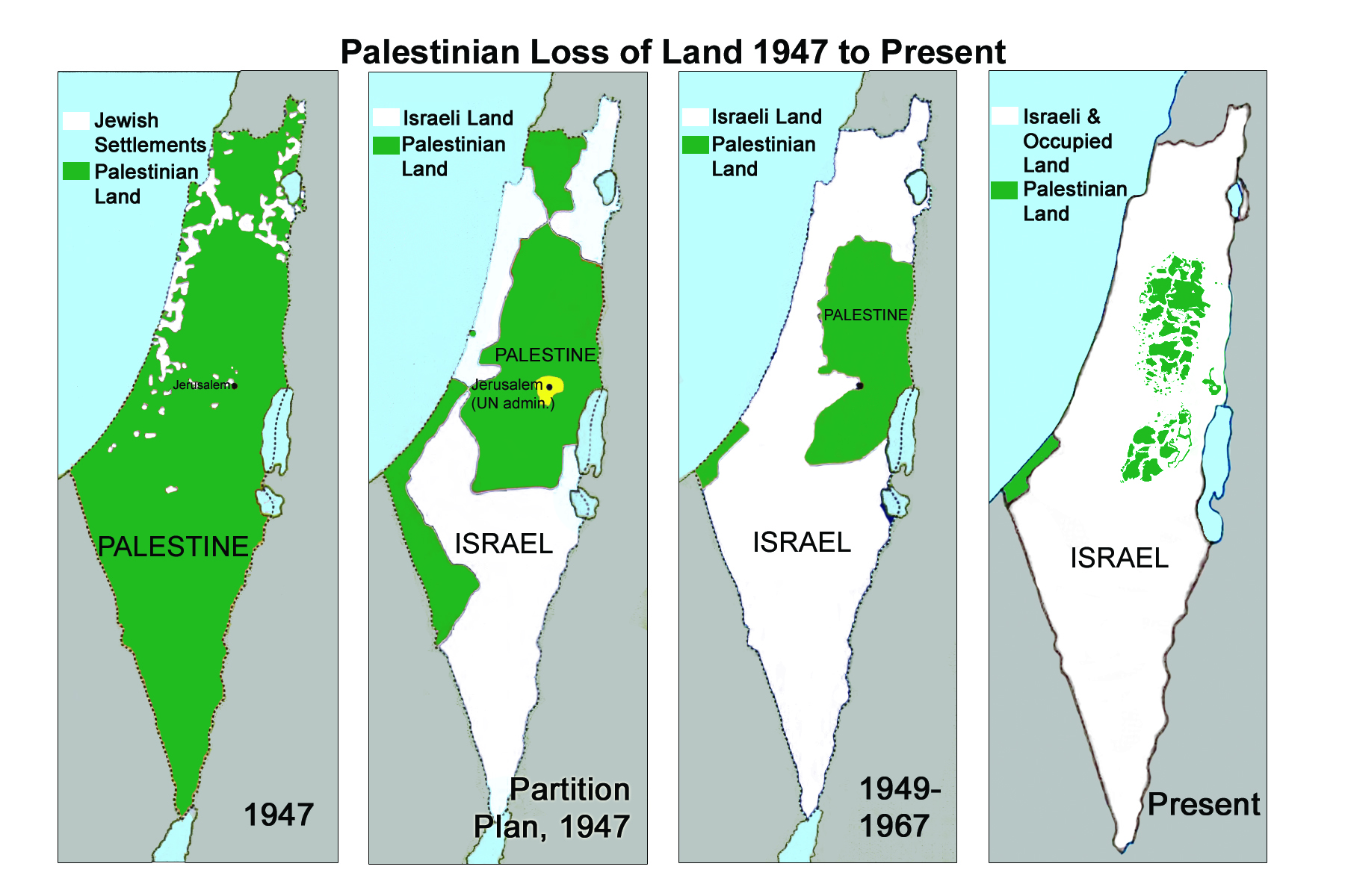
The story of the Palestinians centers on the fact that they and another nation, the Jewish people, have
long existed in the same area. The Jewish nation and its state, Israel, now control most of that territory;
the Palestinians intend to reclaim enough of it to create their own state. The ancient dispute dates back
many millennia to Abraham and his two sons: Isaac, who founded the Jewish nation, and Ishmael, the
symbolic father of all Arabs. The historical ebb and ﬂow in the region of Jews and Palestinians is cloudy
and far too complex to unravel here, but we can pick up the story in 1920 when Palestine was governed
by Great Britain. At that time, Palestinian Arabs were about 90% of the population.

In Europe, however, Zionism gathered strength in the 19th century. Zionism is the nationalist, not
strictly religious, belief that Jews are a nation that should have an independent homeland. This belief
and virulent anti-Semitism in Nazi Germany and elsewhere in Europe accelerated Jewish emigration
to Palestine, swelling the Jewish population there from 56,000 in 1920 to 650,000 by 1948 (along with
about 1 million Arabs). At that point, ﬁghting for control erupted, the British withdrew, and Arab leaders
rejected a UN plan to partition Palestine into a Jewish state and an Arab state. Israel won the ensuing
war in 1948 and acquired some of the areas designated for the Arab state. About 500,000 Palestinians
ﬂed to refugee camps in Egyptian-controlled Gaza and elsewhere; another 400,000 came under the
control of Jordan in an area called the West Bank (of the Jordan River), and 150,000 remained in the new state of Israel (3).

Since then, Israel has fought and won three more wars with its Arab neighbors. In the 1967 war Israel captured considerable territory, including Gaza from Egypt and the West Bank (including East Jerusalem) from Jordan. Both these areas had major Palestinian populations. Victory, however, did not bring Israel peace or security. The key reason is the unresolved fate of the West Bank, which is central to Palestinians' quest for an independent homeland.

The struggle between Israelis and Palestinians for land, security, even survival has created an explosive
situation that has deﬁed resolution for over half a century. Surely, there have been times of progress.
Most signiﬁcantly, a majority of Israelis now grudgingly accept the idea that the Palestinians should
have their own state. And most Palestinians, with equal reluctance, now concede the permanent existence of Israel and that a Palestinian state will be largely conﬁned to the West Bank. However, each time of hope for resolution has been followed by renewed violence.

Proposals for a Palestinian state currently refers to the proposed establishment of an independent state
for the Palestinian people in Palestine on land that was occupied by Israel since the Six-Day War of
1967 and before by Egypt (Gaza) and by Jordan (West Bank) since 1949. The proposals include the
Gaza Strip, which is currently controlled by the Hamas faction of the Palestinian National Authority, the
West Bank, which is administered by the Fatah faction of the Palestinian National Authority, and East
Jerusalem which is controlled by Israel under a claim of sovereignty. The proclaimed State of Palestine is currently recognized by 129 countries. The Israeli military commander exercises rights in accordance with international law, but he is not the legal sovereign of the disputed territory. The permanent sovereignty of the Palestinian people over the natural resources of the Palestinian territories has been recognized by 139 countries. Under agreements reached with Israel, the Palestinian Authority exercises de jure control over many natural resources, while interim cooperation arrangements are in place for others.

The current position of the Palestinian Authority is that all of the West Bank and Gaza Strip should form the basis of a future Palestinian state.The specific points and impediments to the establishment of a Palestinian state are listed below. They are a part of a greater mindset difference. Israel declares that its security demands that a Palestinian entity would not have all attributes of a state, at least initially, so that in case things go wrong, Israel would not have to face a dangerous and nearby enemy. Israel may be therefore said to agree (as of now) not to a complete and independent Palestinian state, but rather to a self-administering entity, with partial but not full sovereignty over its borders and its citizens.
The central Palestinian position is that they have already compromised greatly by accepting a state covering only the areas of the West Bank and Gaza. These areas are significantly less territory than allocated to the Arab state in UN Resolution 181. They feel that it is unacceptable for an agreement to impose additional restrictions (such as level of militarization, see below) which, they declare, makes a viable state impossible. In particular, they are angered by significant increases in the population of Israeli settlements and communities in the West Bank and Gaza Strip during the interim period of the Oslo accords. Palestinians claim that they have already waited long enough, and that Israel's interests do not justify depriving their state of those rights that they consider important. The Palestinians have been unwilling to accept a territorially disjointed state.

(http://en.wikipedia.org/wiki/Proposals_for_a_Palestinian_state)

